Access DAI and select “B2R GL Inquiry DSS”
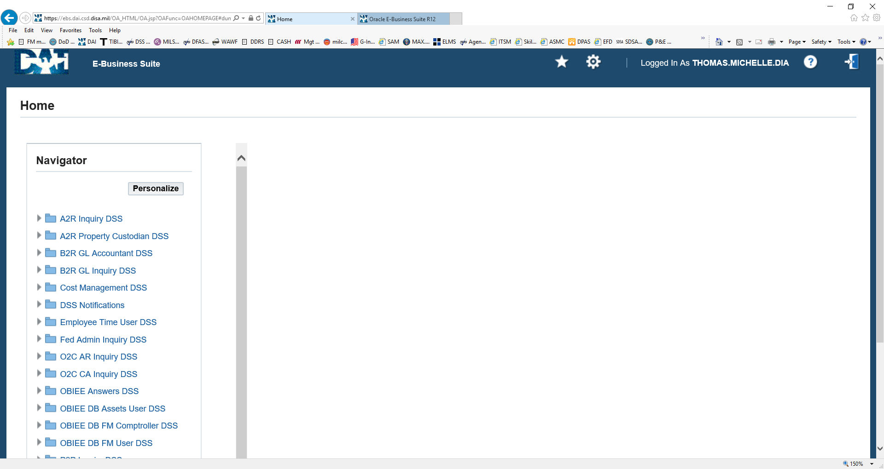

Select “Other: Report: Run”
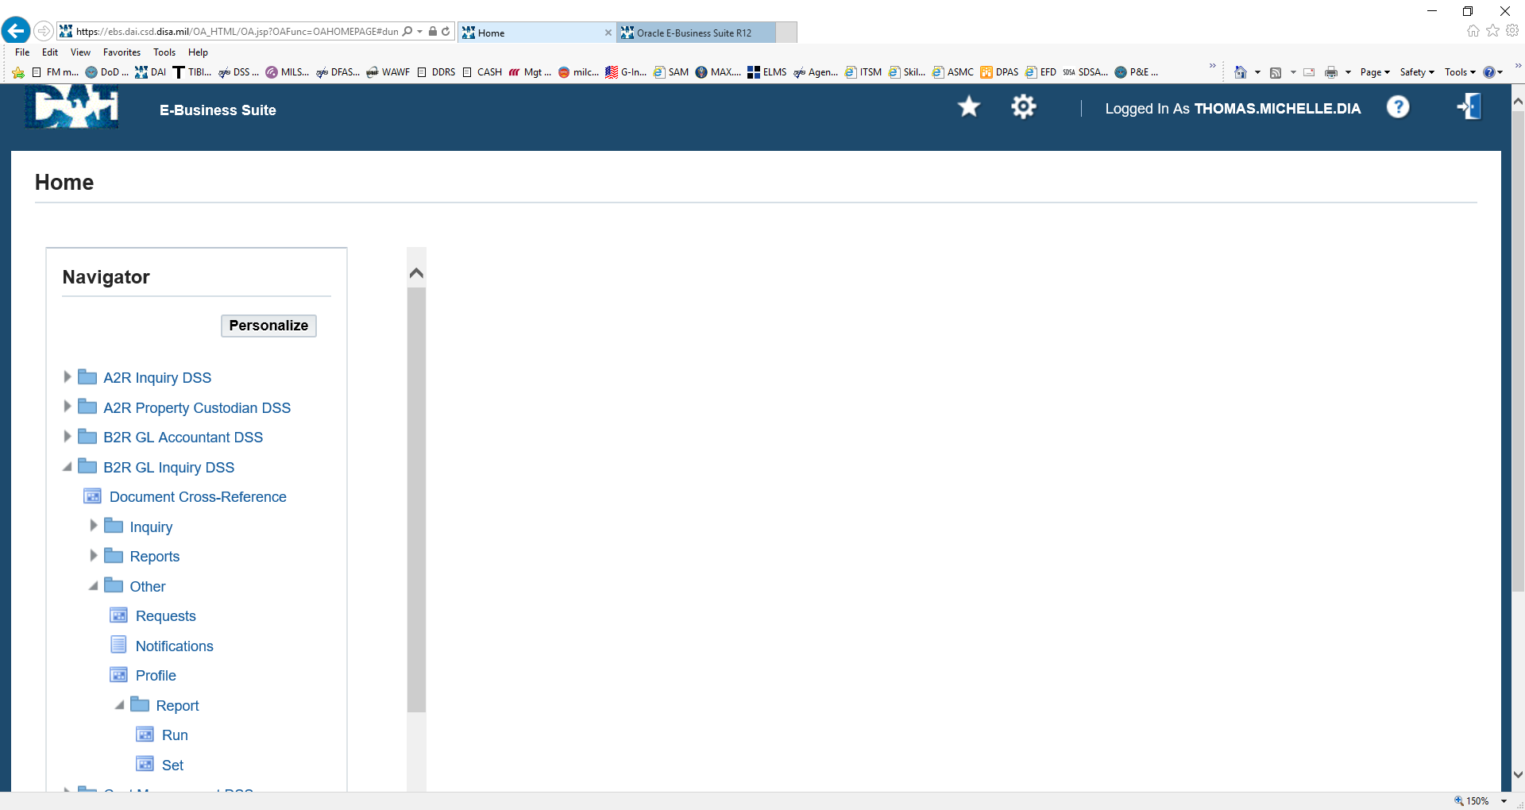

Select “Single Request“and click OK
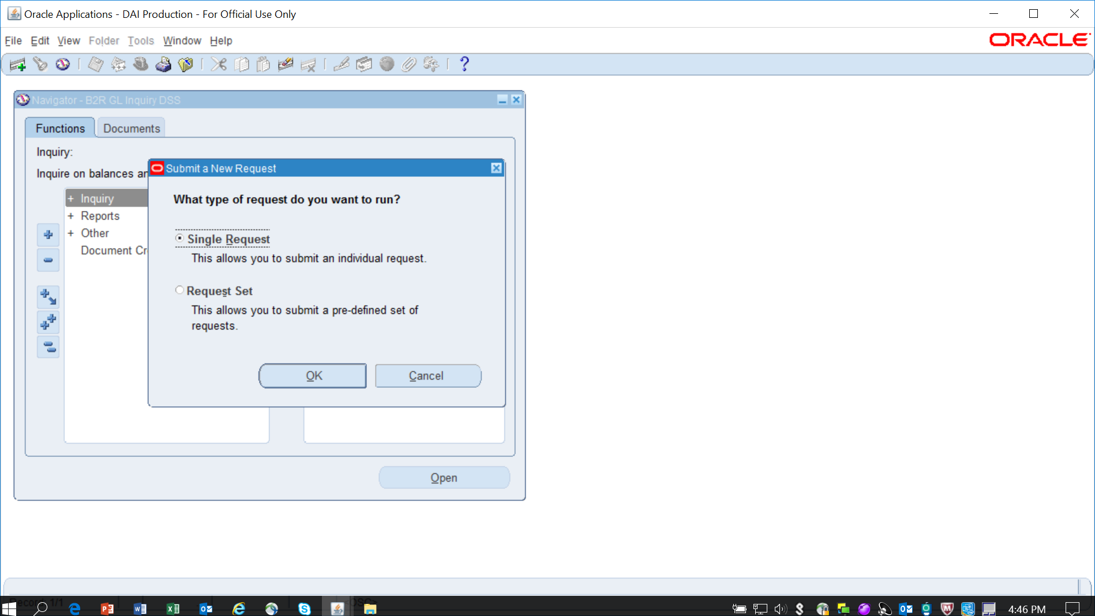

In the Name field enter “%1002%” and hit Enter
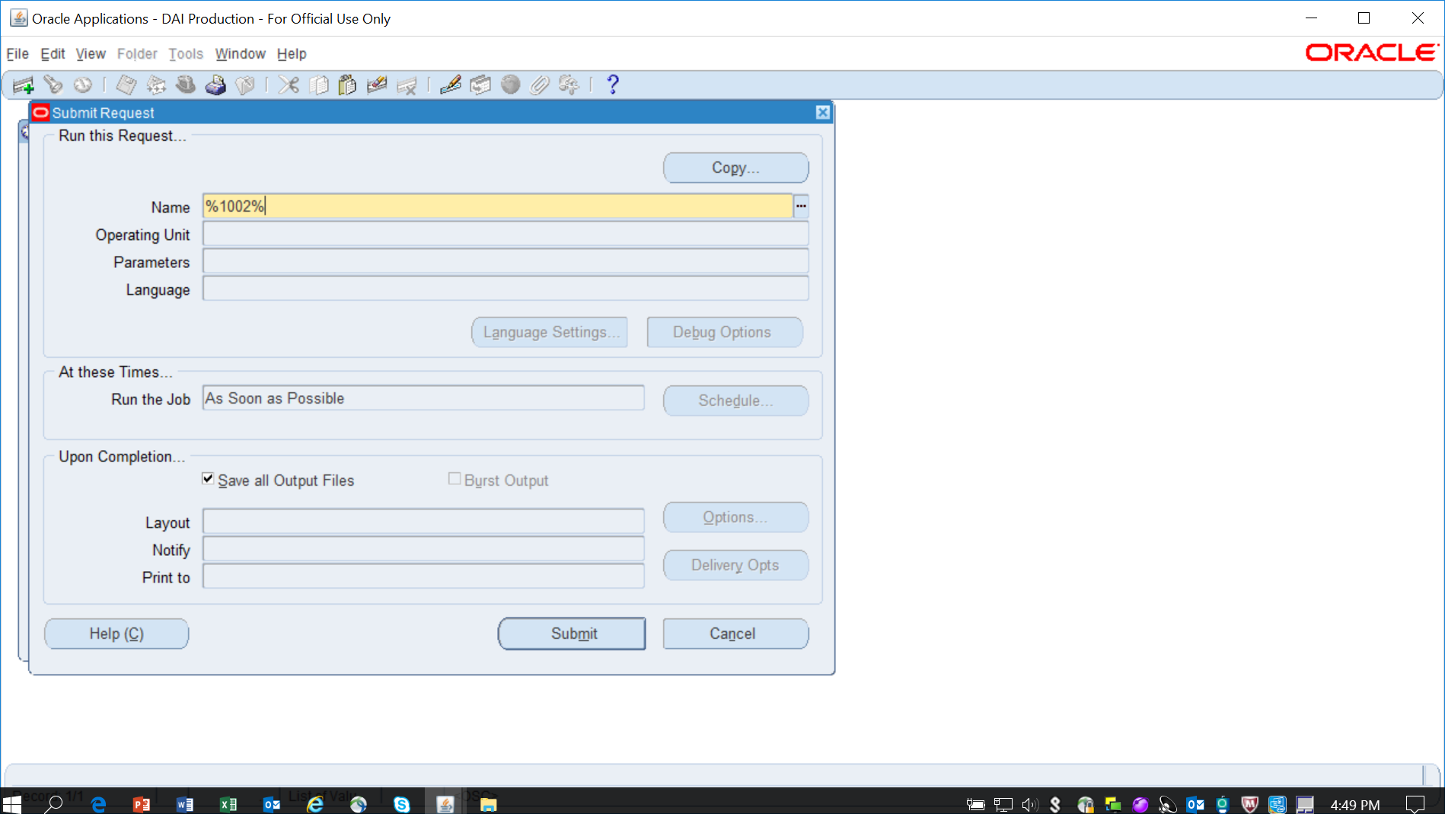

Select the “XXDAI 1002 REPORT XL” and “OK”.
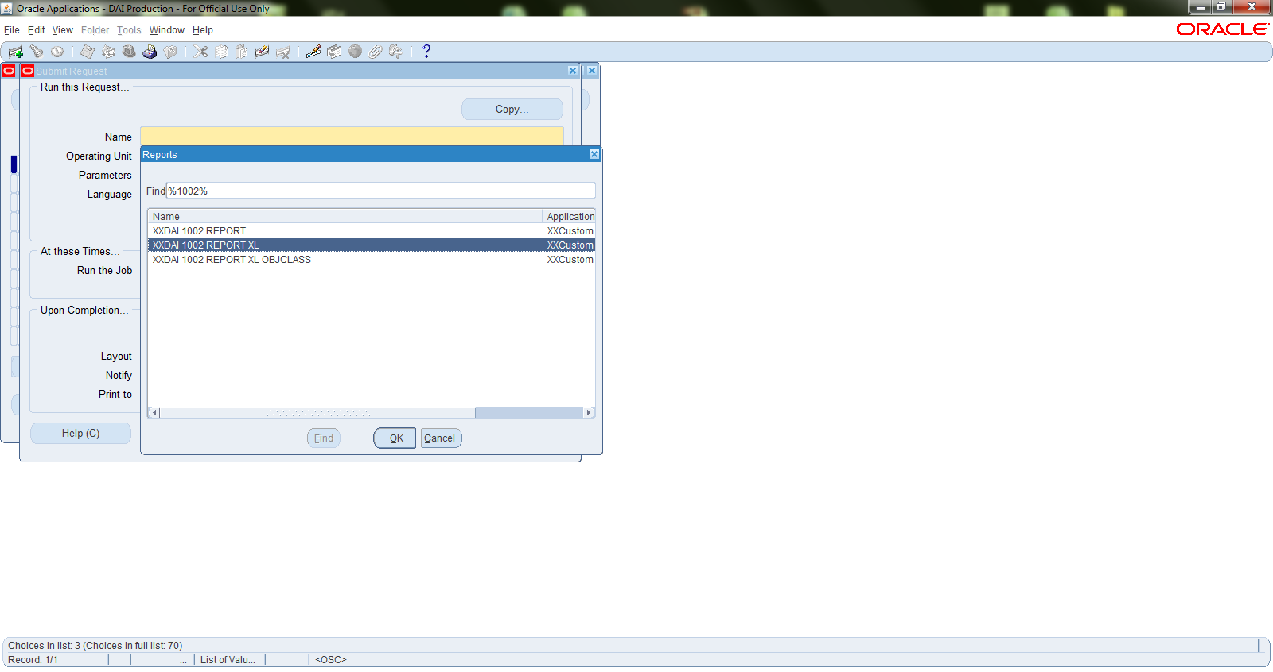

Enter the parameters of the 1002 you want to request (for example below is requesting from O&M FY13D through BRAC) then select OK
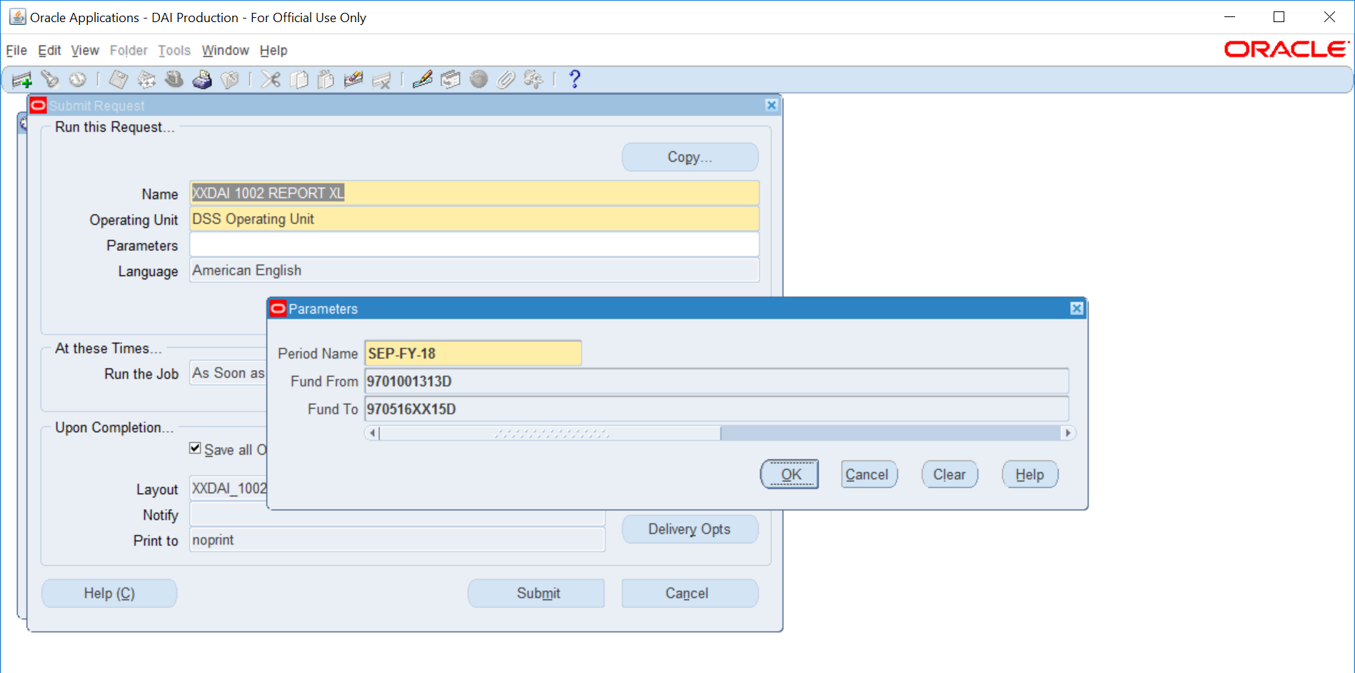

Select Submit
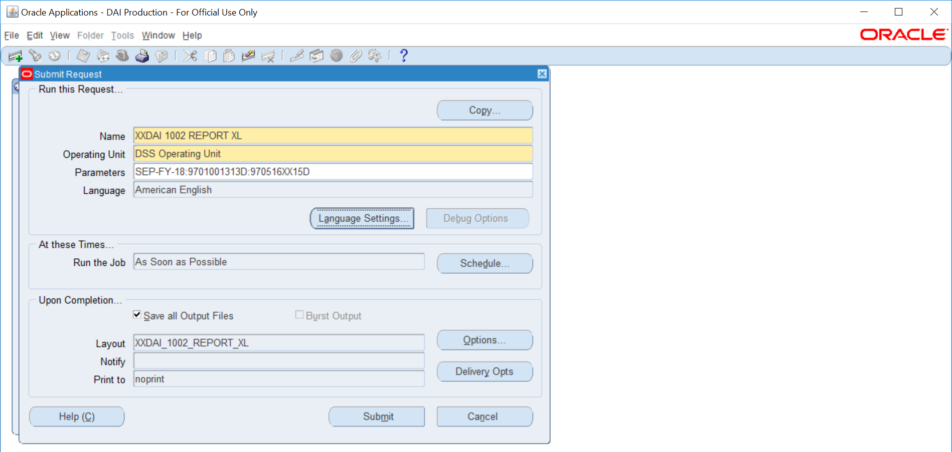

Select “No” if this is the only report you are running “Submit another request?”
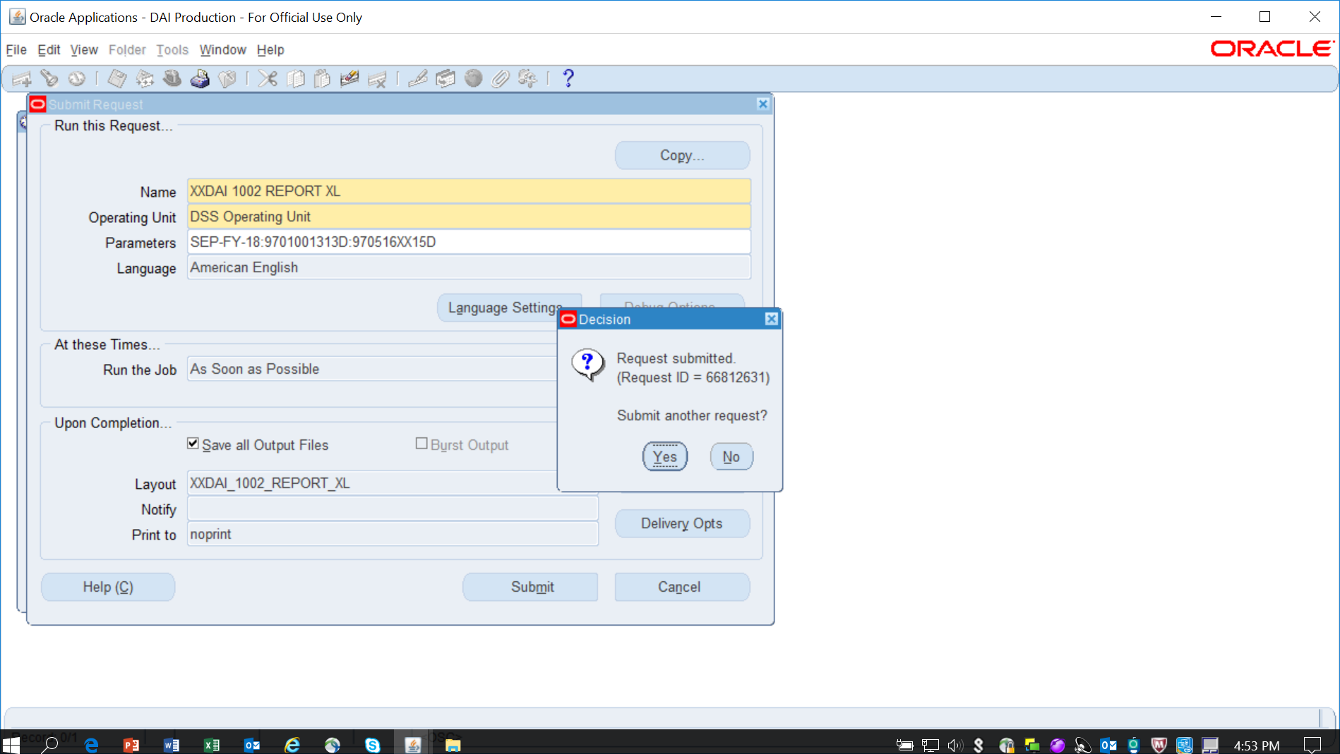

Select “View: Requests”
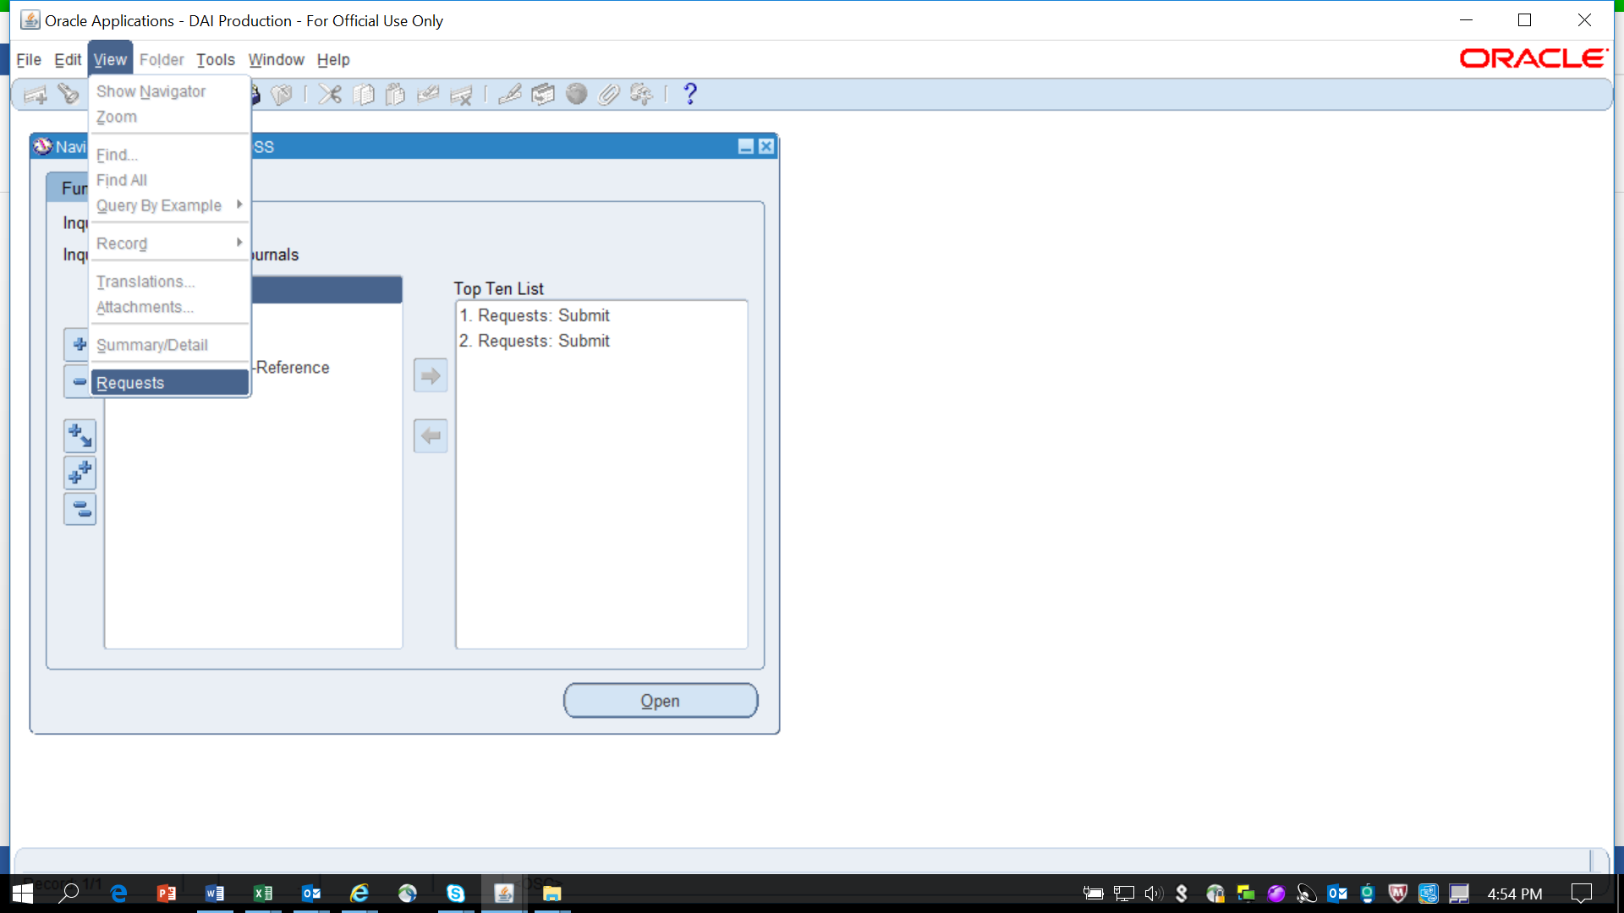

Select “All My Requests” then “Find”
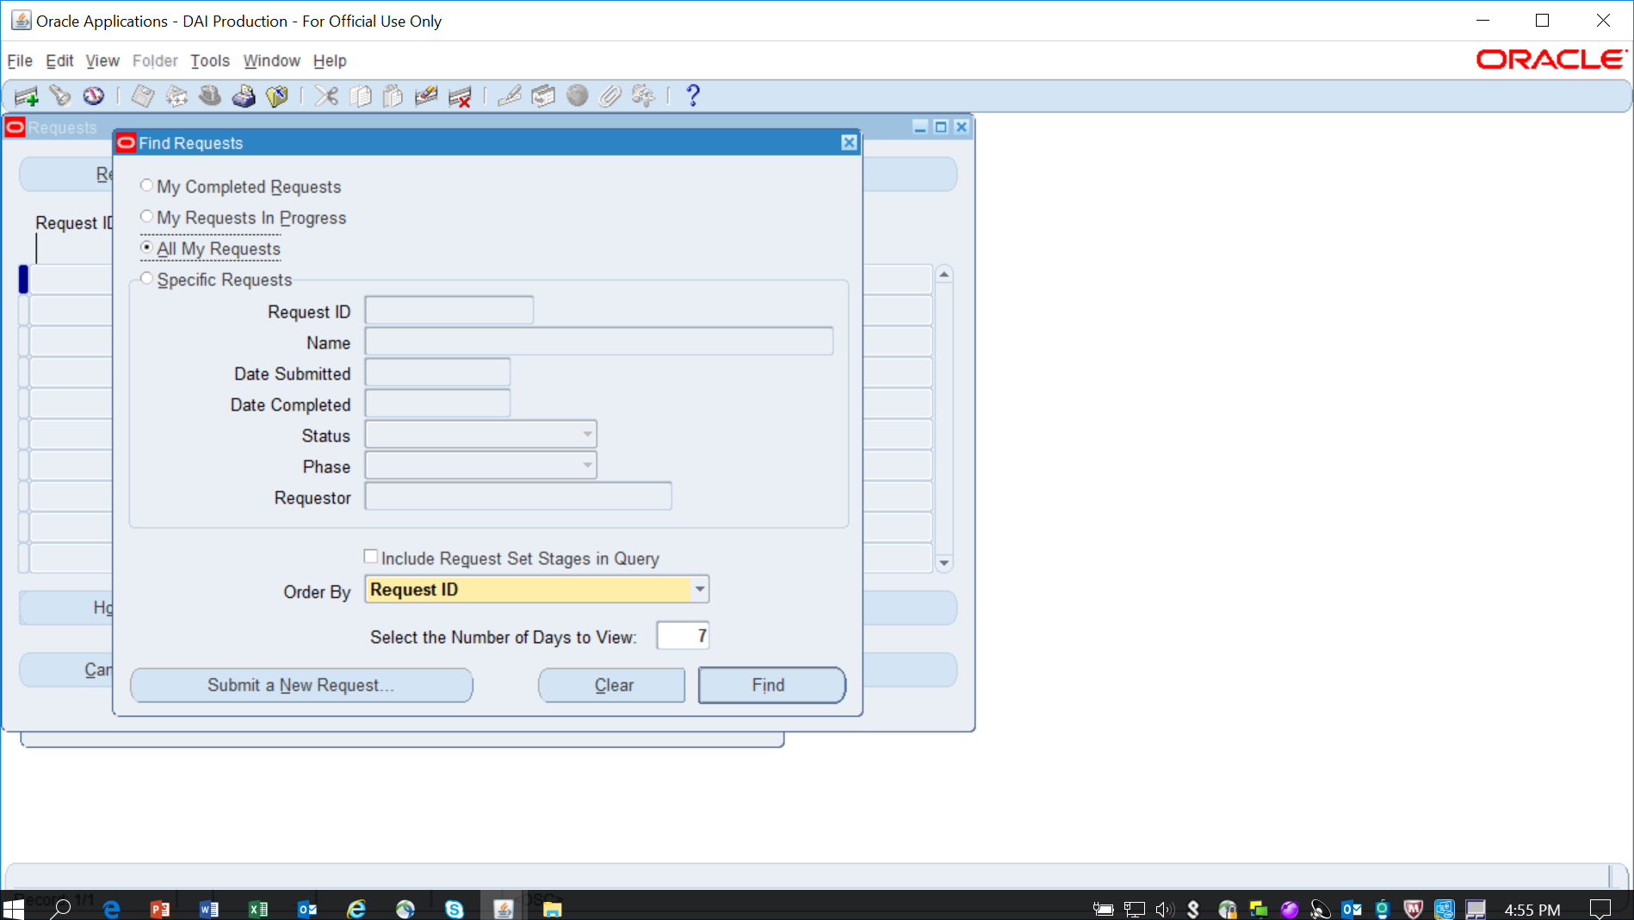

Select “View Output” to view the AR (M) 1002
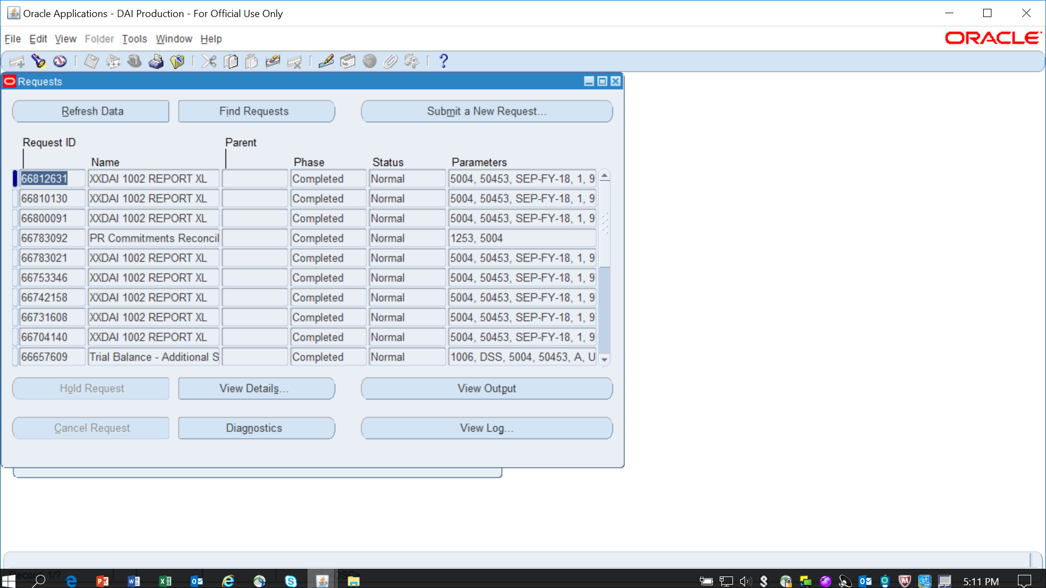

Select “Save As” (due to our version of Microsoft this report will no longer open).
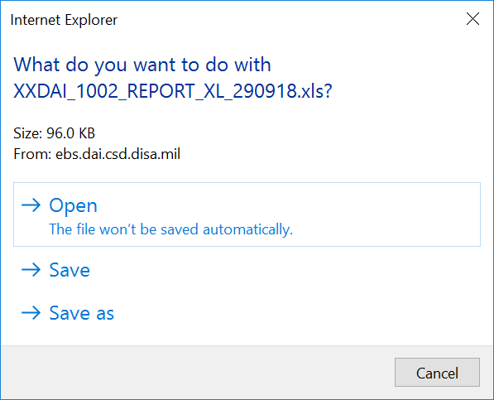

Save on hard drive C:\Users\michelle.thomas\AppData\Roaming\Microsoft\Excel
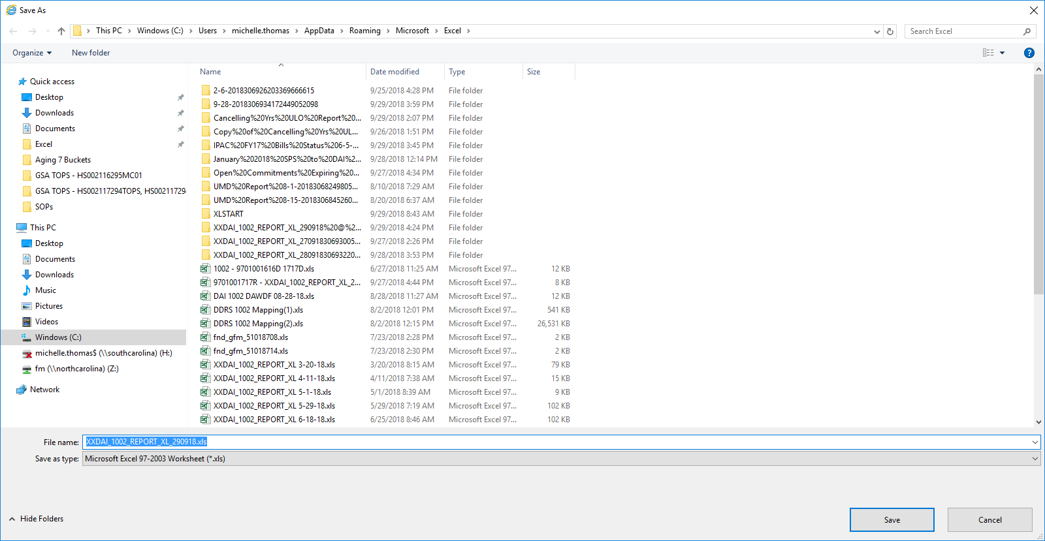

Select “Open Folder”
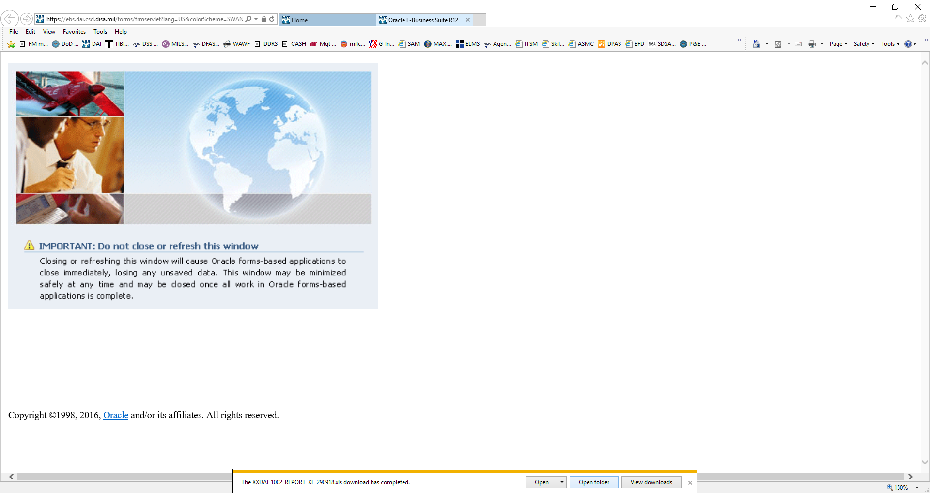

Open the Report you just saved – Select “Yes”.
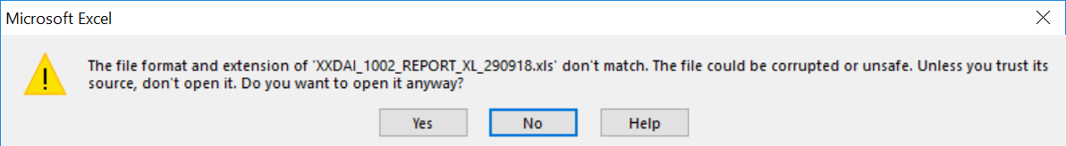

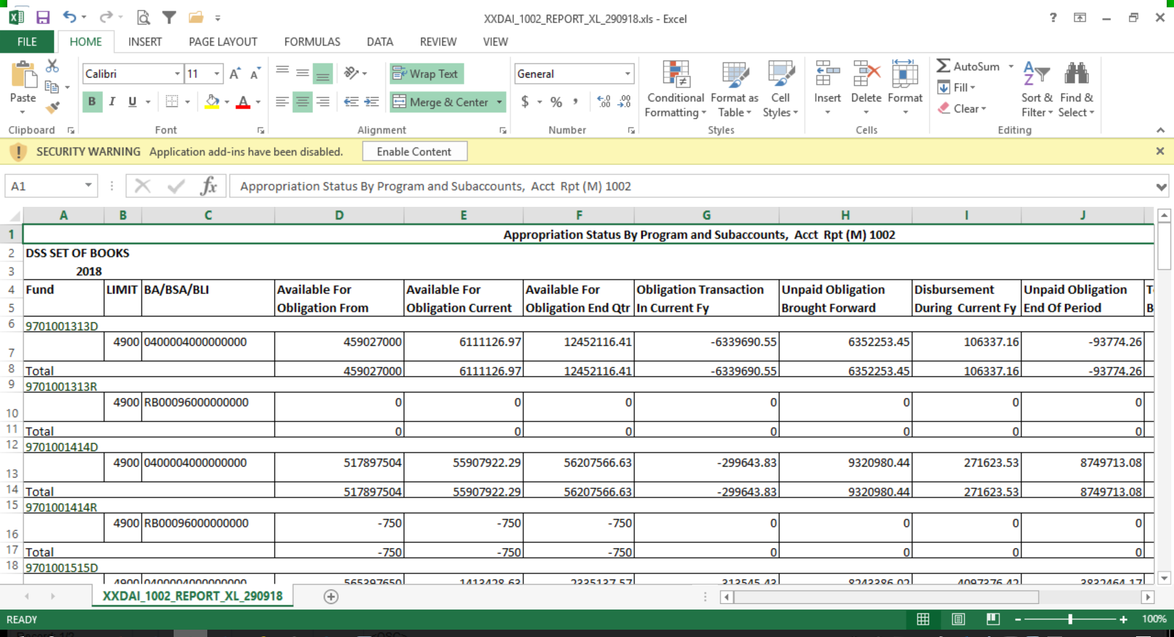

Data Columns:
- Fund: This is the fund that the balances represent. The report is sorted by fund and the Year Limit BSA/BLI. Each page is separated by Fund.
- Year Limit BSA/BLI (Column A): This is the Year Limit BSA/BLI combination that the balances represent. The report is sorted by fund and a separate row is created for each unique Year-Limit-BA/BSA/BLI combination.
- Available for Obligation from Inception (Column B): This represents the budgeted amount available for that fund and BA/BSA/BLI across all fiscal years to date.
- Avail for Obligation Current FY (Column C): This represents the total available funding amount for the current fiscal year for that fund and BA/BSA/BLI.
- Avail for Obligation End of Quarter (Column D): This represents the total available funding amount as of the end of the current quarter for that fund and BA/BSA/BLI.
- Obligation Transactions in Current FY (Column E): This is the total amount of Obligation transactions for the current fiscal year for that fund and BA/BSA/BLI.
- Unpaid Obligations Brought Forward (Column F): This is the amount of unpaid obligation brought forward from the prior fiscal year for that fund and BA/BSA/BLI.
- Disbursements During Current FY (Column G): This is the total amount of disbursement transactions for the current fiscal year for that fund and BA/BSA/BLI.
- Unpaid Obligations End of Period (Column H): This is the balance of unpaid Obligations at the end of the period chosen in the report parameters for that fund and BA/BSA/BLI.
- Total Unobligated Balance (Column I): This represents the total available funding for obligations as of the end of the period chosen in the report parameters.
- Commitments Outstanding (Column J): This is the total amount of Commitment (open) that has not been obligated for that that fund and BA/BSA/BLI.

