We’re excited to show you how OneNote Desktop 2016 is most unused of the Microsoft Applications, but yet one of the most powerful. We’ll empower you with solutions. We’ll conduct this training over 2 sessions, first one was last month and now part 2. October, we explained the structure of OneNote, then we added 23 videos explaining how each customize ribbons works from 316 to choose from. See below: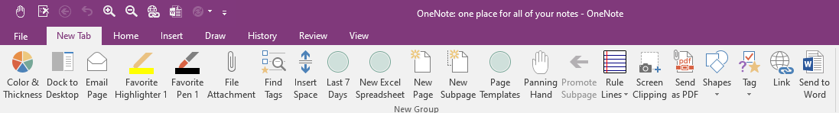
Important Tip: 1) You never have to do a “Save”, because OneNote saves everything once entered. 2) You will go back to the exact place you left, when reopening OneNote. 3) CTRL + Z is undo

Now, it’s time to provide examples and show you some cool tips of how to setup. First one, we’ll show you how an organization provided Status of Funds, Financial Working Groups (FWG), and Financial Management Board (FMB) briefing for the past three years up to current. Secondly, we’ll show you how another organization tracked their taskers using OneNote, one of the best solutions I’ve seen. The amazing features OneNote has to make it easy to keep it organized and provide quick analysis of open and closed taskers. Thirdly, we show you another solution of how an organization used it for training and storage of files and links to important documents.

As always, we’ll provide short videos from start to finish of the training.

