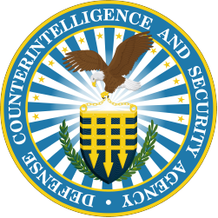
SF 1164 Process
- Once the SF 1164 is completed it must be signed by all three: the employee, the supervisor, and an additional RA. It will be rejected if all signatures are complete.
- The RA will review for accuracy and completeness, enter the LOA in the SF 1164, then enter it into DAI, upload all pertinent documentation, and submit it for certification (a PR is created).
- The Certifyer will review for accuracy and completeness then certify for the auto generated Obligation and Invoice to be created.
- Within an hour of the PR Certification the Obligation will be created
- Within an hour of the Obligation the Invoice will be created.
- The Accounting Team will review the Invoice for accuracy and completeness then submit for payment.
- DFAS will batch twithin 1-2 days and the employee will be paid within 2 – 5 business days.

Rejected Invoices
- If the Invoice is Rejected the Accounting team will notify the RA via email for corrective action.
- The RA corrects/updates necessary information and uploads it to the Obligation, then notifies the Accounting team via email it’s complete.
- The Accounting team will manually correct the Invoice in DAI and upload any additional or corrected documentaion and Initiate for Certification.
- Once Initiated, the Accounting team will review for accuracy and completeness then submit the Invoice for payment.

Note: for certifying in DAI you must have a 577 card of file

