- Daily Reports (3)

- The NULO Report
  - Log into DAI from DSS home page.
    - Click on “DSS DAI Timekeeping System” in left panel.
    - Click on “Access DAI Timekeeping” button in upper right side of panel.
    - Click “OK” in next screen.
    - Select your DOD EMAIL certificate in “Select a Certificate” screen.
    - Enter your PIN, if prompted.

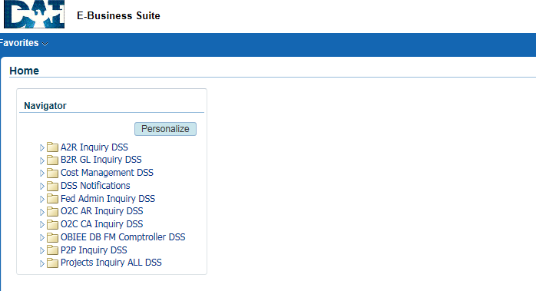
  - Click on the “OBIEE DB FM Comptroller DSS” link.

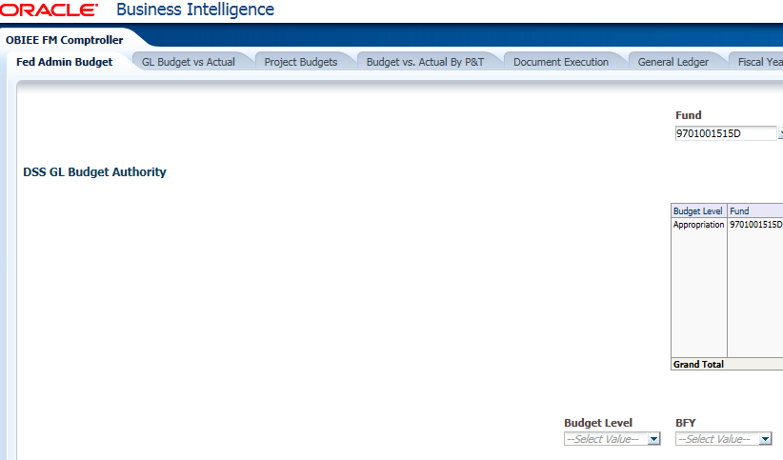
  - Click on the “Document Execution” tab.

  - Click on the “Negative Unliquidated Obligations” link.
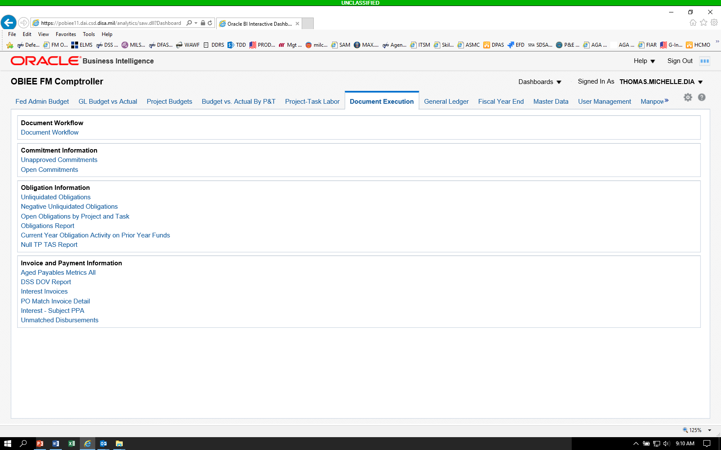
- If the query returns a “No Results” message, this lets you know you currently do not have any NULOs.
- If a NULO(s) exist, update the files as follows:
  - Click the double arrow, ( ), below the table, to ensure the complete report is visible before saving.
  - Export and save the report.

  - Exporting the report.
    - Scroll down to the bottom of the report until the command line is visible.
    - Click on “Export.”
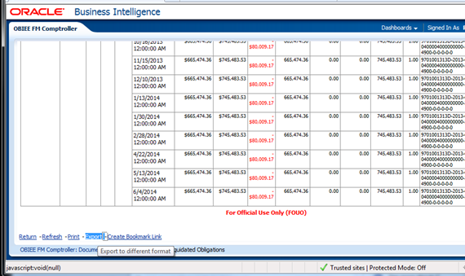

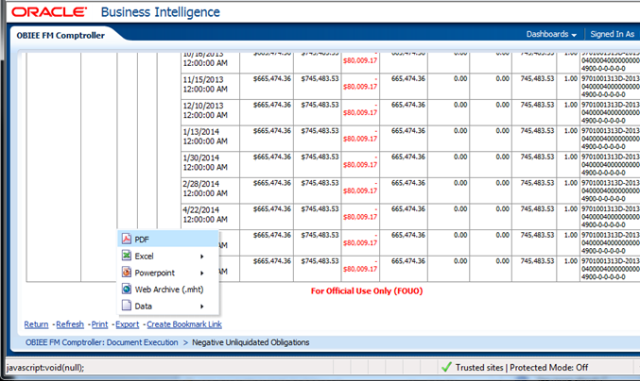
    - Click on “PDF,” then click on “Open,” when the banner pops up to ask “Do you want to open or save Negative Unliquidated Obligations” report.
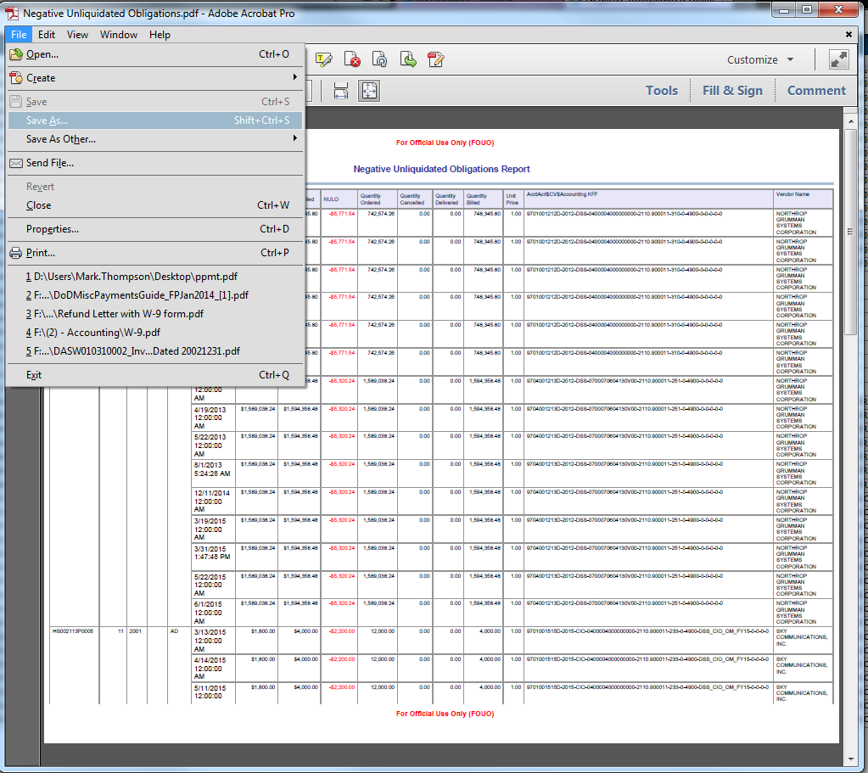
    - Click on “File,” then “Save As.”

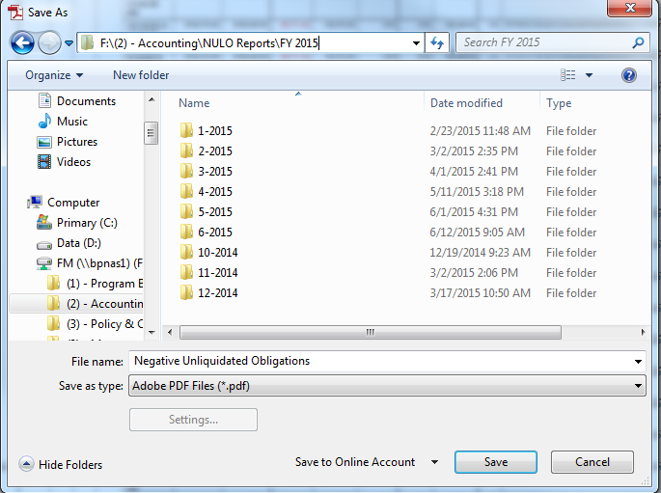
    - In the left panel, under “Organize,” click “FM (\\bpnas1)(F:),” then “(2) – Accounting,” then “NULO Reports” (this will required you to scroll down (far right scroll bar) to find this file), then the current “FY” folder, then the current month (m-yyyy) folder.

    - Click in the “File name” field at the bottom of the screen, and change the file name to reflect the following name convention: “NULO m.dd.yyyy.”
    - Click the “Save” button.

  - Update the Excel NULO Status file.
    - In the same folder that holds the NULO pdf file saved from the steps above, or a prior month’s folder if it is a new month, open the latest Excel NULO report and add new NULO amounts to the worksheet.
    - The line number for each NULO amount on the pdf NULO report is the root cause. Enter information for each line item from the pdf report to the Excel file.
    - Highlight new NULO amounts in yellow; un-resolved NULO amount(s) will remain highlighted until resolved.
    - Once completed with the update, click “File,” then “Save As,” using the following naming convention – “NULO Report m.dd.yyyy.”

  - Send an email to inform the buyer about the variance between the amount invoiced and the amount encumbered; include the supervisor in the carbon copy (CC) line. The subject of the email is “Invoice Issue.”
  - To find the buyer for the purchase order, do the following:
    - Take note of the Purchase Order number from the Excel NULO Report.
    - Select “P2P Inquiry DSS” from the DAI Home screen.

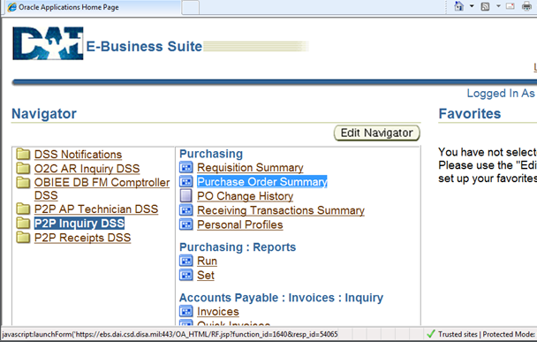
- Under Purchasing, select Purchase Order Summary

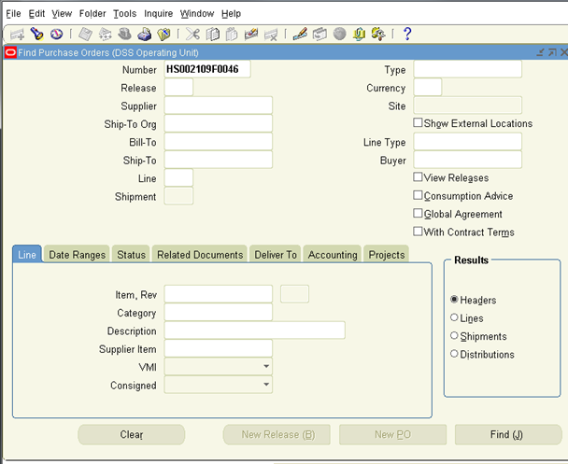
- Enter the Purchase Order number in the “Number” field above and click the “Find (J)” button
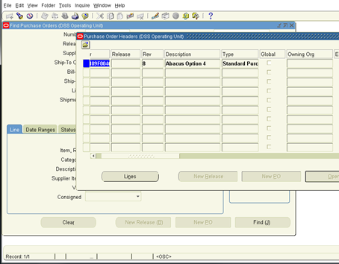
At the “Purchase Order Headers” screen above, scroll the white bar to the right of the screen until the Buyer’s name is visible.
  - Send the updated files as attachments to the Supervisor

- Open Obligations Report
  - Log into DAI from DSS home page.
    - Click on “DSS DAI Timekeeping System” in left panel.
    - Click on “Access DAI Timekeeping” button in upper right side of panel.
    - Click “OK” in next screen.
    - Select your DOD EMAIL certificate in “Select a Certificate” screen.
    - Enter your PIN, if prompted.
  - Click on the “OBIEE DB FM Comptroller DSS” link.
  - Click on the “Document Execution” tab.
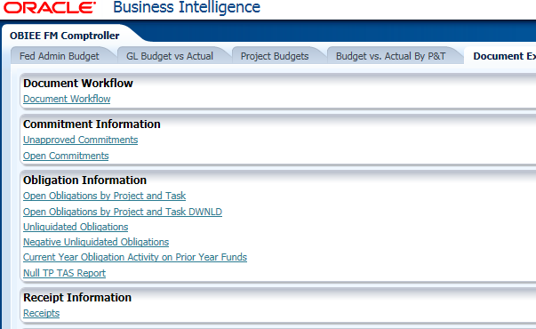
  - Click on the “Open Obligations by Project and Task” link.
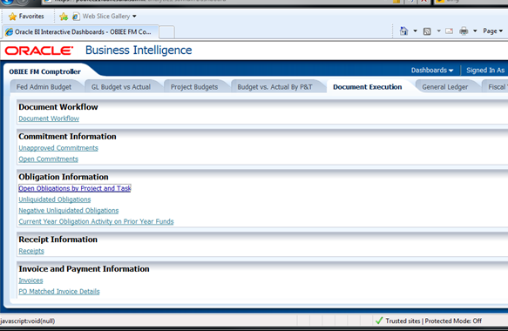

  - Select the Open Obligations by Project and Task link

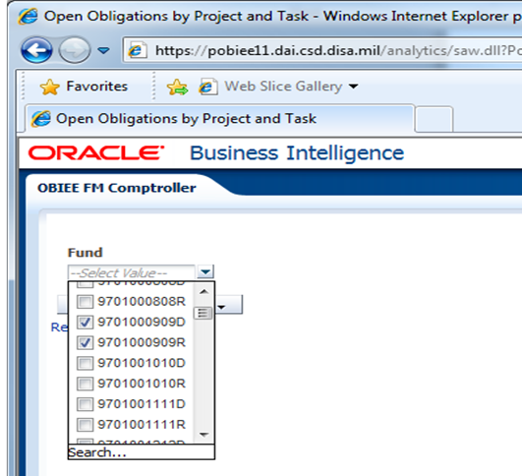
- Select the three Expired funds for O&M (0100), RDT&E (0400), and BRAC (0512)
- Click outside of the drop down window
- Select the “Next” button until “Vendor Name” appears, then select “ok”
Once a report is generated, scroll over to the far right of the screen

- Click on the “Active Encumbrance” header to highlight the column
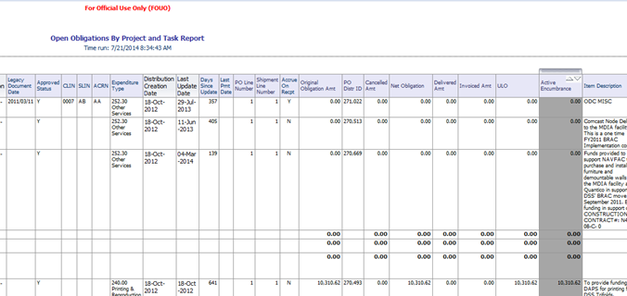

- Scroll down to the bottom of the report until total Open Obligation amounts by fiscal year are visible 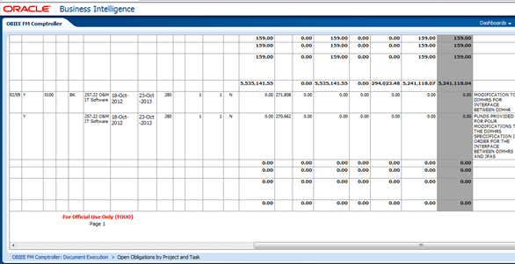
The above totals should align with the row headers for Fiscal Year Totals on the left of the report.

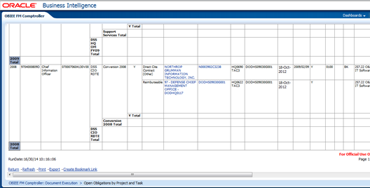

- If total Open Obligation amount(s) are the same as those from the prior day’s report, inform the Supervisor that there are no changes in Open Obligation total(s).
- If total Open Obligation amount(s) has changed compared to the prior day’s report, update by exporting the report to a CSV Format file.
Scroll across to the left and down to the bottom of the report until the following commands are visible.
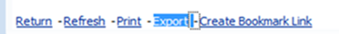

- Click on Export

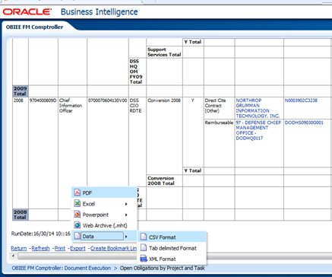
- Click on Data, click on CSV Format, click on Open when prompted.

Keep data with the following column headers and delete all the rest:
- BFY
- Fund
- Project Name
- Task Name
- Vendor Name
- PO Number
- Net Obligation
- Invoiced Amt
- ULO
- Item Description
Prepare the file to show sub-totals and grand total similar to those in a prior day’s report.
Save as an Excel file in the following folder:
F:\(2) - Accounting, July 2014\Open Obligation Reports\FY 2014\July 2014
Inform the Supervisor of any changes to Open Obligations daily with an Excel file attachment. Note: if there are no changes to Open Obligations total, retrieve the last saved “Open Obligation” Excel file and change the date in the file name to current date. Inform the Supervisor and include the Excel file as an attachment on Mondays, Wednesdays, and Fridays (no attachments needed if there are no changes to Open Obligations on Tuesdays and Thursdays).
- UMD Report
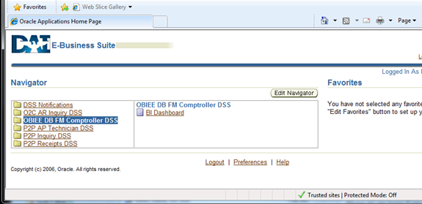
- Select the OBIEE DB FM Comptroller DSS link
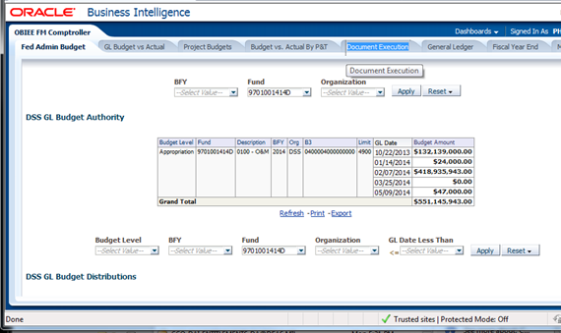
- Select Document Execution Tab
- Select Unmatched Disbursements under Invoice and Payment Information
- Once report is displayed, be sure to click the double arrow to ensure COMPLETE report is visible before exporting.
- Scroll across to the left and down to the bottom of the report until the following commands are visible.
- Click on Export
- Click on Data, click on CSV Format, click on Open when prompted.

- Weekly Reports (7)
- Interest and Invoice reports (Three in OBIEE _ Document Execution tab)
- Invoice Report (no parameters required)
Click “Next” three times until “Vendor Name” appears
Click “ok”
Once a report is generated, click
Export _ Data _ CSV format
Open and format the file by adding a title at the top row,
“Invoices as of current date”
Select current year 2014 invoices by “Date” column, and sort by newest to oldest.
Save as an Excel format file in the F shared drive
F:\(2) - Accounting, July 2014\12-1 Interest and Invoice Reports
And select the appropriate Quarter, Month folders, and File Name
- Interest _ Subject PPA Report
Parameter = month FY
Click “ok”
Once a report is generated, click
Export _ Data _ CSV format
Same as above, insert a title at the top row
“Interest _ Subject PPA as of current date”
Add a “total sum” for “Payment Amount” column, change the ink color to red
Save as an Excel format file in the F shared drive
F:\(2) - Accounting, July 2014\12-1 Interest and Invoice Reports
And select the appropriate Quarter, Month folders, and File Name
- Interest Invoice Report
Parameter = month FY
Once a report is generated, click
Export _ Data _ CSV format
Same as above, insert a title at the top row
“Interest Invoices as of current date”
Add a “total sum” for “Interest $” column, change the ink color to red
Save as an Excel format file in the F shared drive
F:\(2) - Accounting, July 2014\12-1 Interest and Invoice Reports
And select the appropriate Quarter, Month folders, and File Name
Open last week’s Power Point file, “Interest Penalty Accrued”, and Excel file “Interest Penalty Status”. Update the Excel status file to reflect data reported on this week’s Interest Invoice report. File Save As (use the same file name with current date).
Copy data from the Excel file and paste them to the Power Point slides. File Save As (use the same file name with current date)

- Two reports in P2P Inquiry
- Invoice Status Report
Under Purchasing
Reports
Click Run
Click Single Request
Click ok
In the yellow “Name” field, type %aging%
Click Submit
Select Invoice Aging Report, click ok
Expand the new window to see all field widths
“Include Invoice Detail” field = yes
“Include Site Detail” field = yes
“Aging Period Name” field = DAI Aging
Click ok, ok, submit
Click “Refresh Data” frequently until all phases are completed
Click “View Output”
Change page setup to Landscape
Print (change scaling to 80%)
Save as a text file format in the F drive
F:\(2) - Accounting, July 2014\12-1 Interest and Invoice Reports
And select the appropriate Quarter, Month folders, and File Name
Open last week’s Power Point file, “Commercial Invoice Weekly Status Report”, and Excel file “Commercial Invoice Status”. Update the Excel status file to reflect data reported on this week’s Invoice Status report. File Save As (use the same file name with current date).
Copy data from the Excel file and paste them to the Power Point slides. File Save As (use the same file name with current date)

- Invoice on Hold Report
Under Accounts Payable
Other » Requests
Click Run
Click Single Request
Click ok
In the yellow “Name” field, type %hold%
Click “Submit”,
Select “Invoice on Hold Report” from the list
Click ok, and ok again
**Don’t put in any parameters on next pop up screen
Click ok, Click Submit

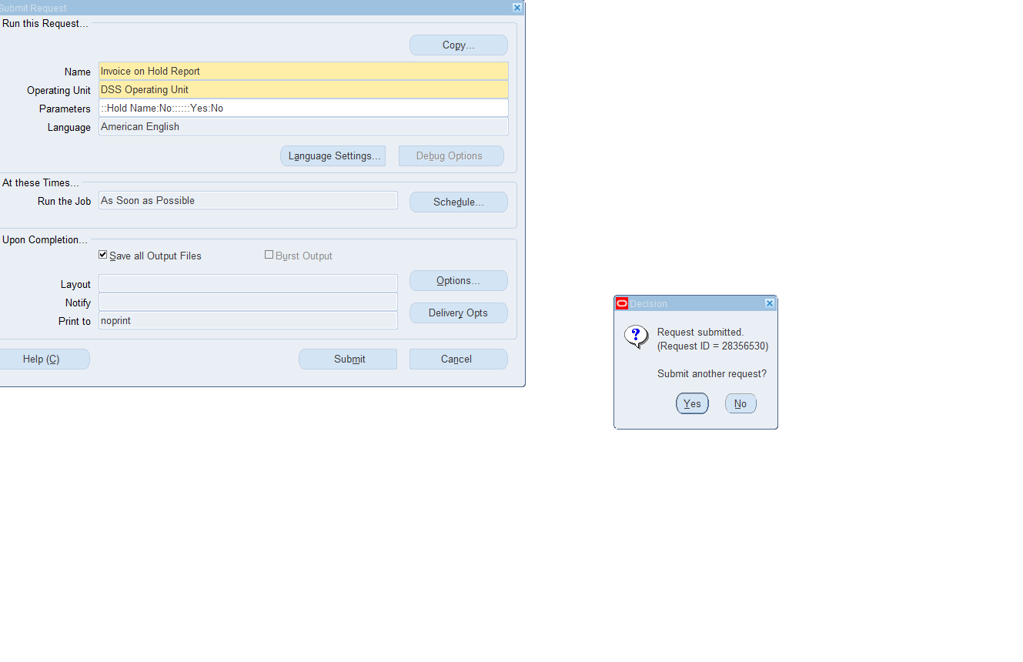
Click No for “Submit another request?”
Click “Refresh Data” frequently until all phases are completed
Click “View Output”
Save as a text file format in the F drive
F:\(2) - Accounting\Accounting Reports\Invoice on Hold
And select the appropriate Quarter, Month folders, and File Name
Open last week’s Power Point file, “Commercial Invoice on Hold Weekly Status”, and Excel file “Commercial Invoice on Hold Status”. Update the Excel status file to reflect data reported on this week’s Invoice on Hold report. File Save As (use the same file name with current date).
Copy data from the Excel file and paste them to the Power Point slides. File Save As (use the same file name with current date)

- Aging Reports
- Aging Receivables 7 Buckets Report
- In DAI select O2C AR Inquiry DSS. Select Inquiry: Control: Requests/Run
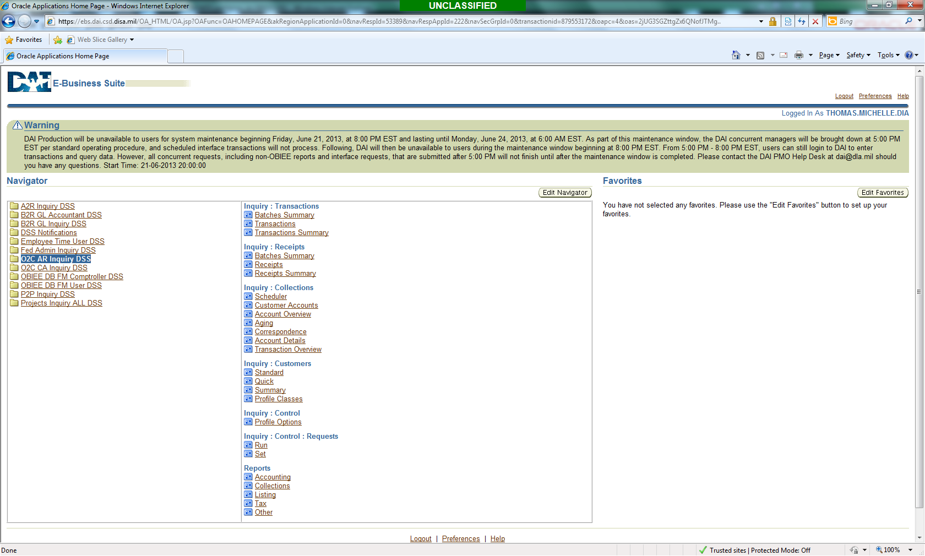
- In the Name field type “%aging%” and select Submit
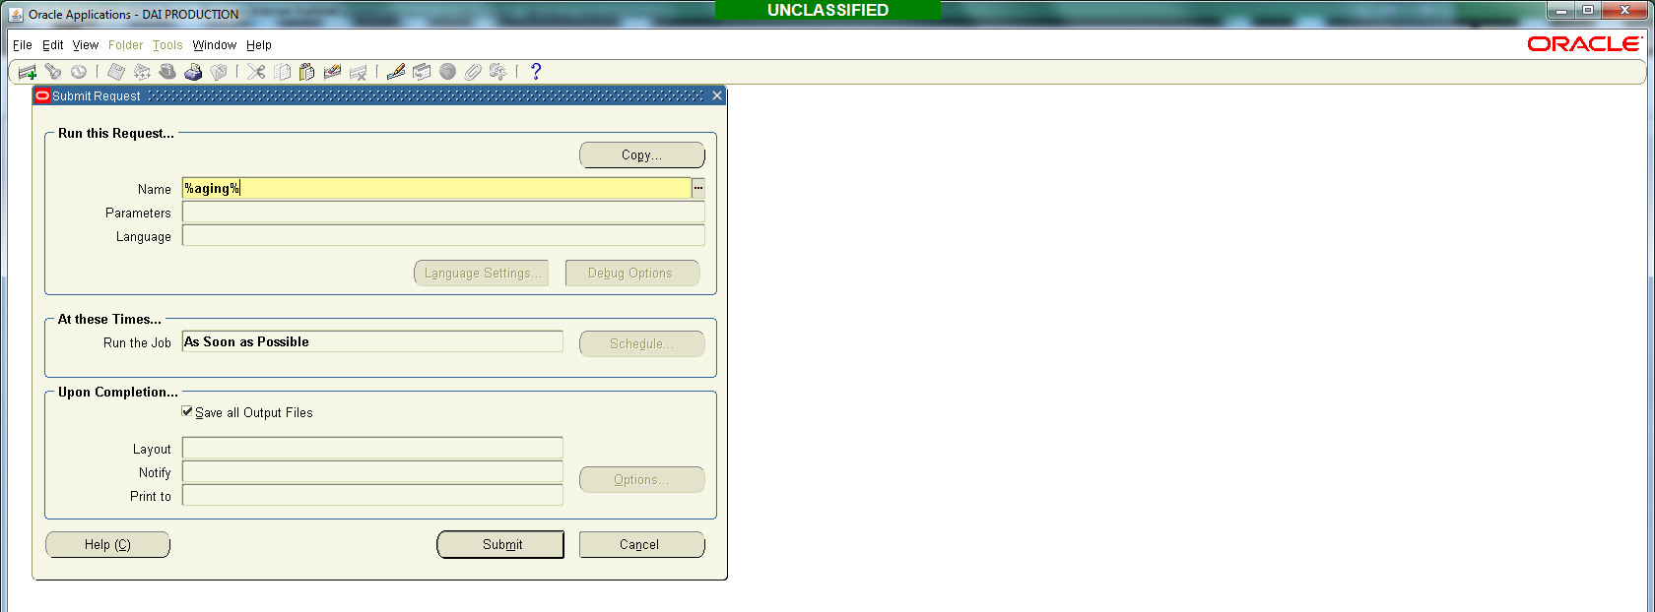

- Select the Aging – 7 Buckets Report and select OK.
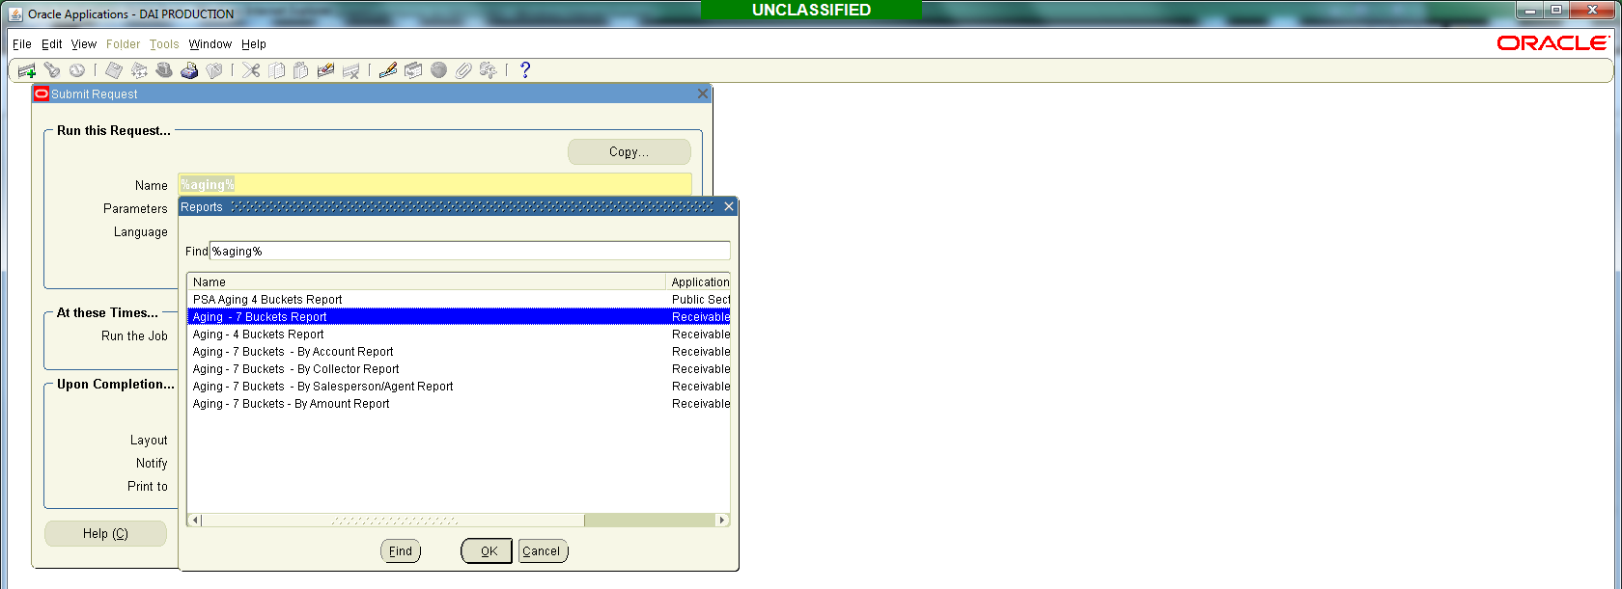

- Enter the criteria below and select OK.

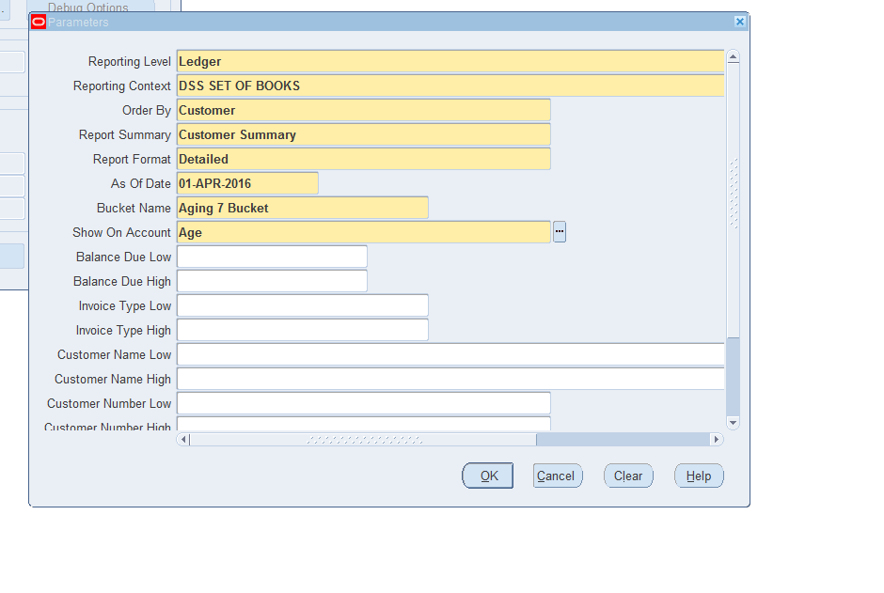
- Select Submit.
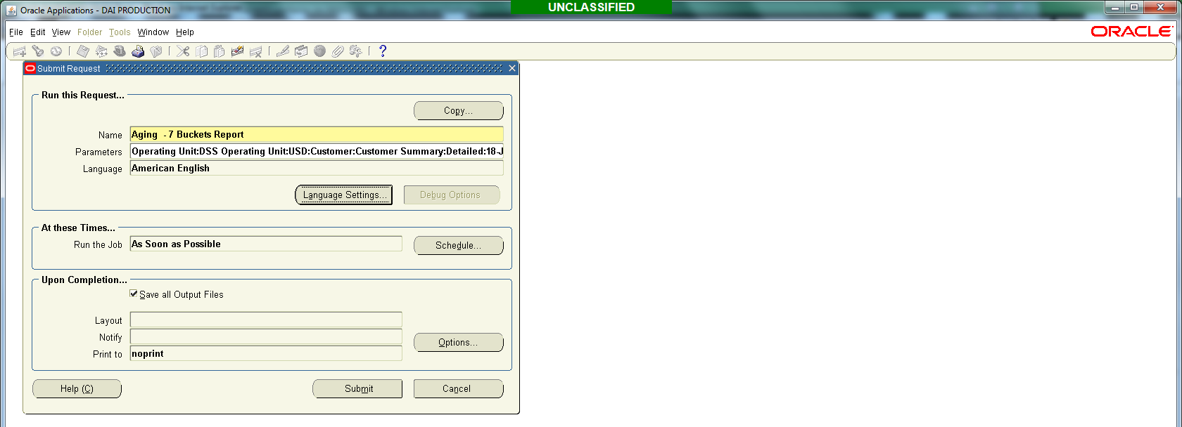

- Refresh Data.
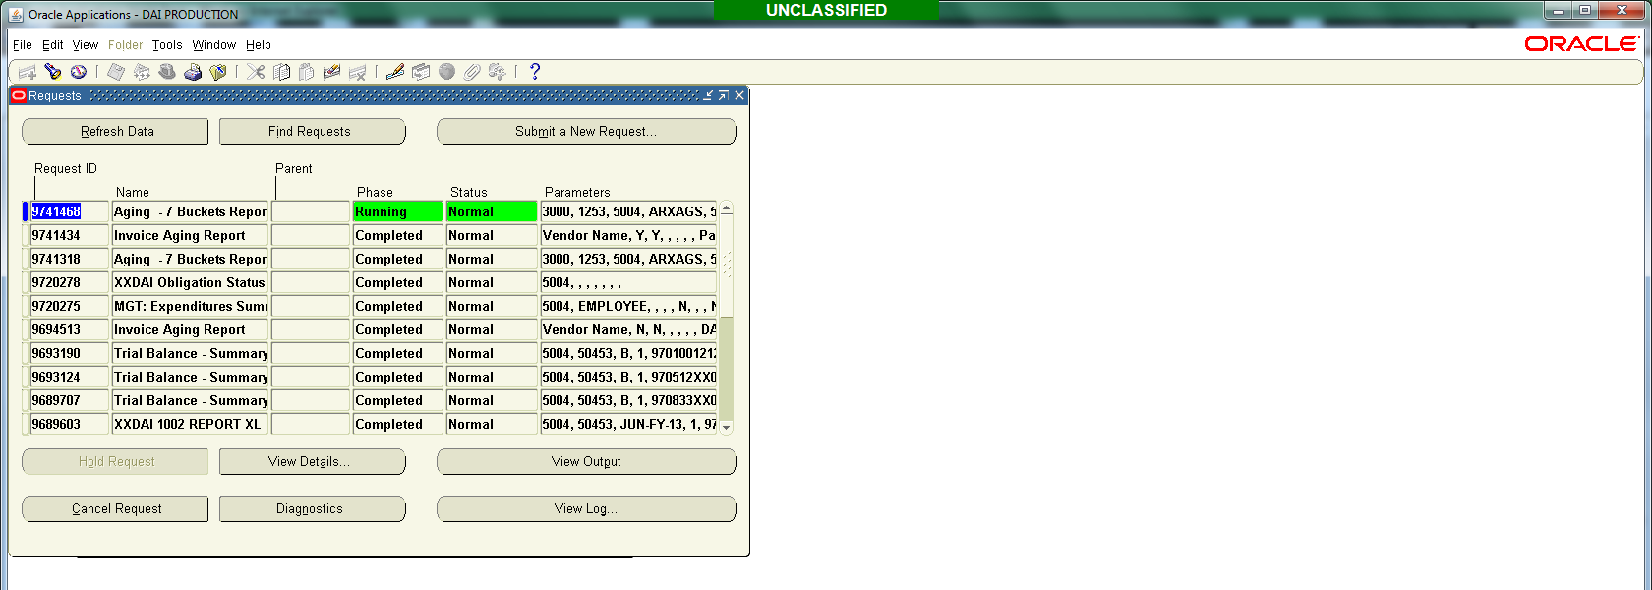
- Once the Phase column is “Complete” select View Output.

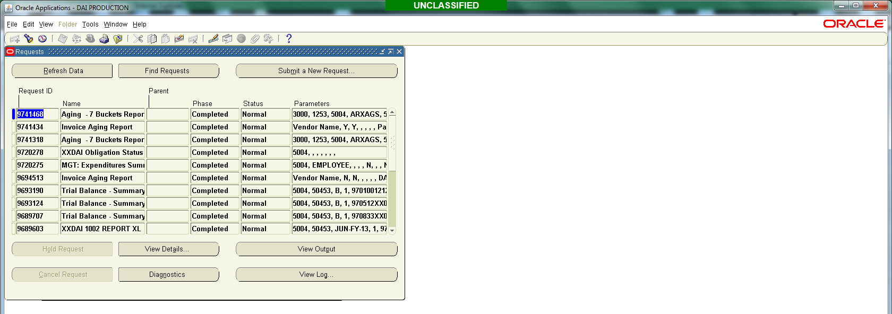
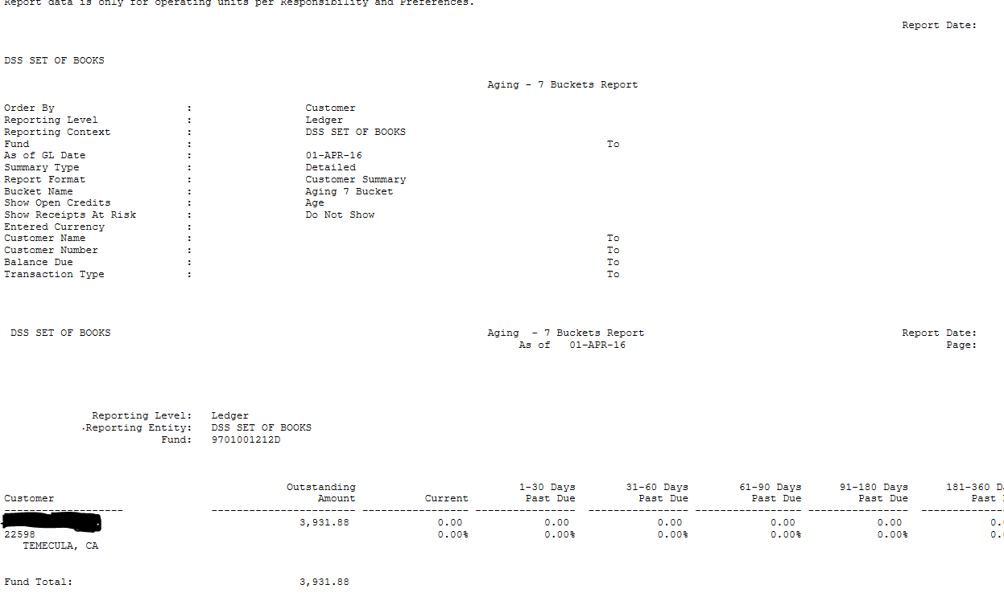

2) Aging Payables Report
- In DAI select P2P Inquiry DSS. Select Accounts Payable Other Requests/Run.
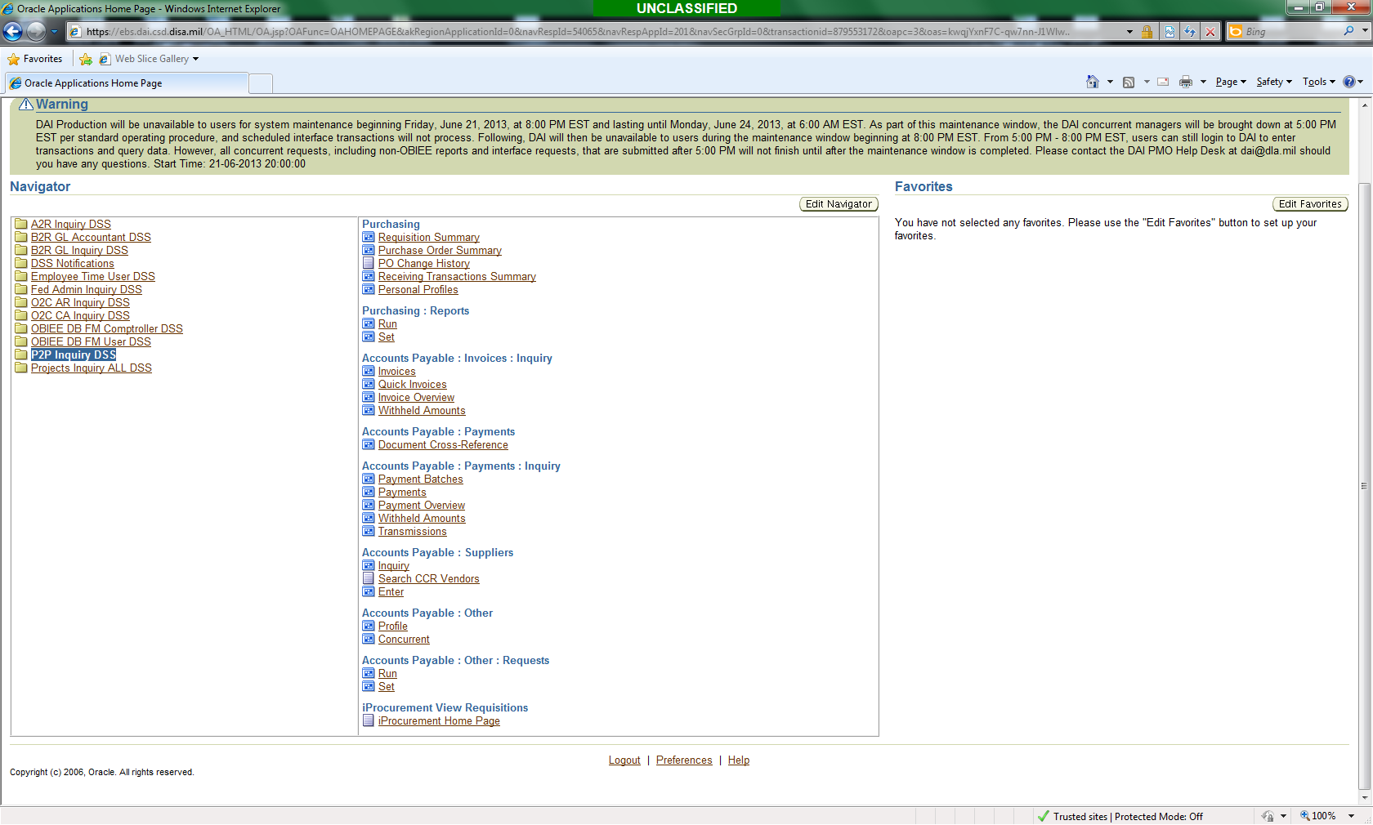
- In the Name field type “%aging%” and select Submit.
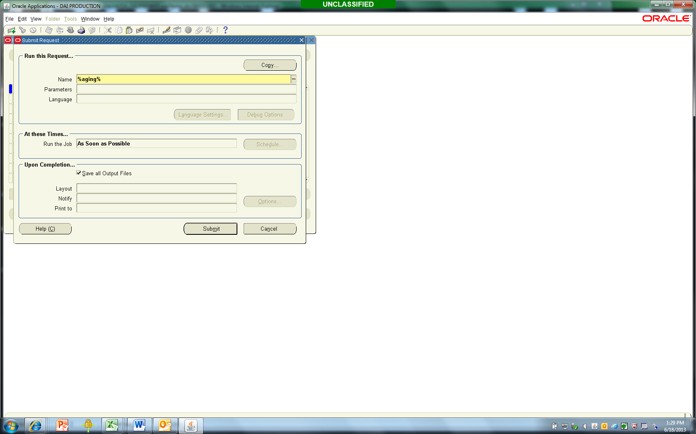

- Select the Invoice Aging Report and OK

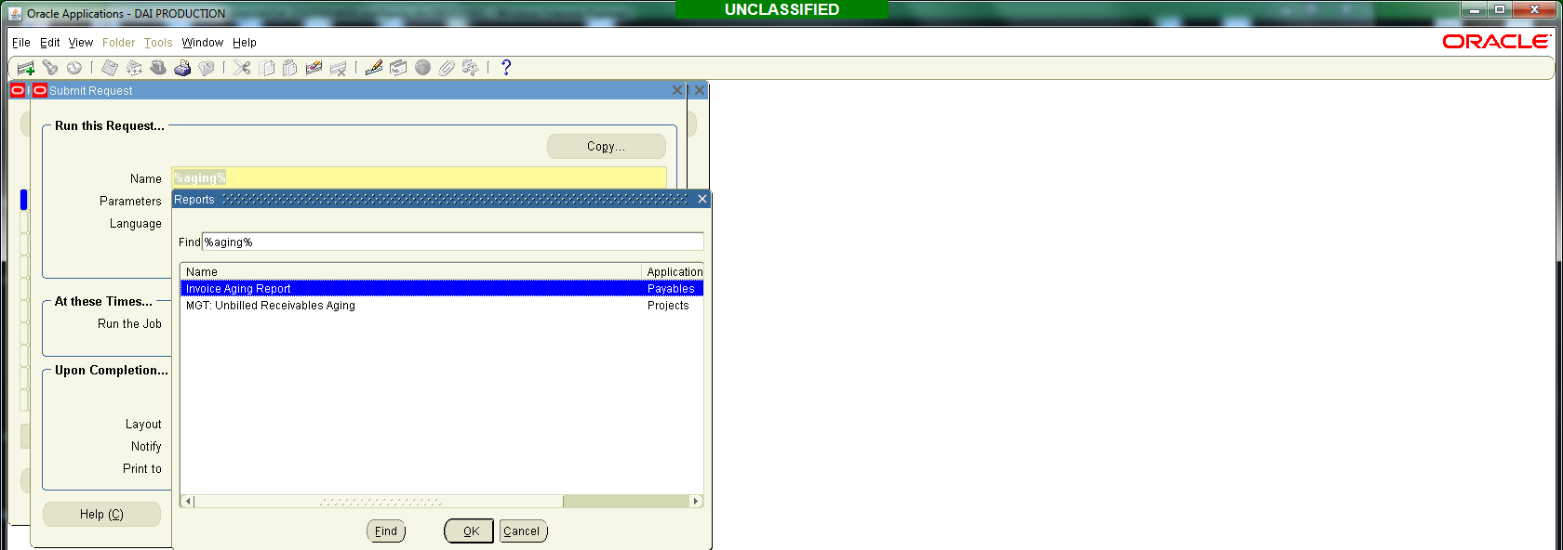
- Enter the criteria below and select OK.
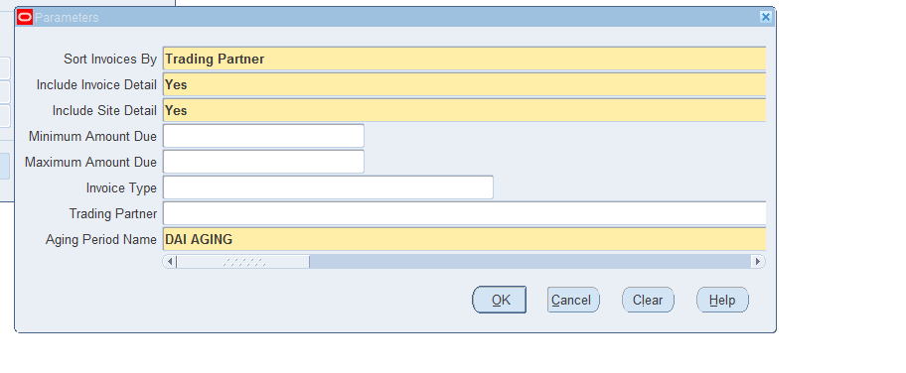
Select OK.
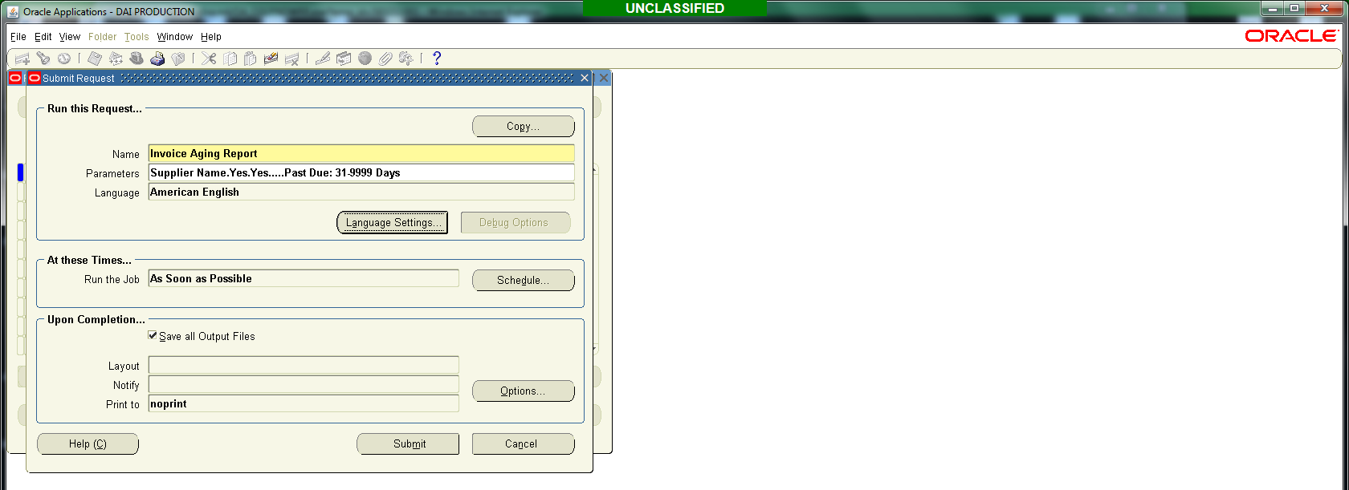
Select Submit.
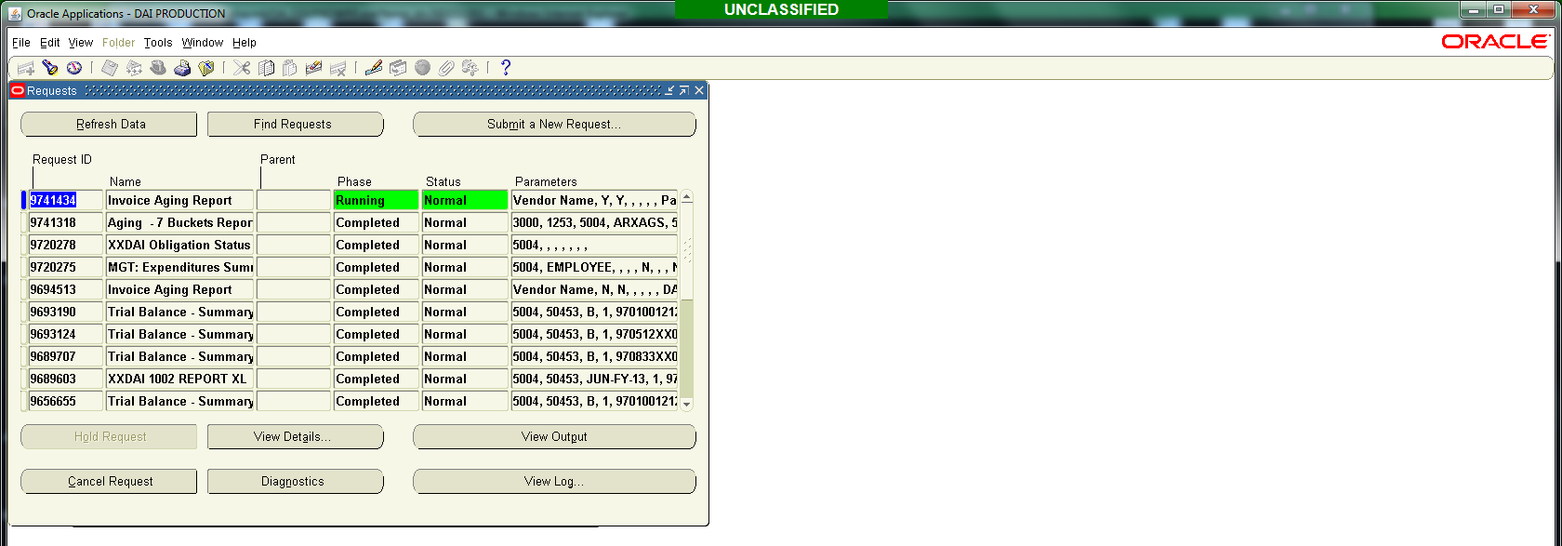
- Refresh Data.
- Once the Phase column is “Complete” select View Output.
