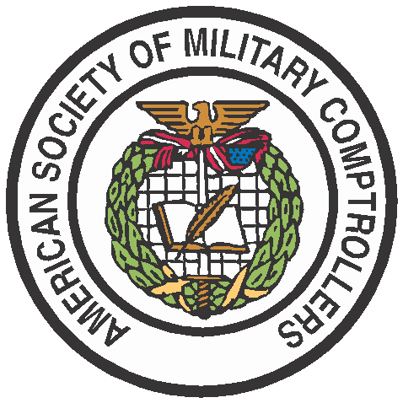
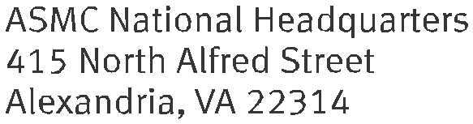

PRESS RELEASE
FOR IMMEDIATE RELEASE Media Contact: Melissa Blacketer
(703) 549-0360
blacketer@asmconline.org

ASMC Holds First Meeting of the Planning, Programming, Budgeting, and Execution (PPBE) Reform Task Force

Alexandria, VA (June 28, 2022) –The American Society of Military Comptrollers (ASMC) held the first meeting of the PPBE Reform Task Force on July 7, 2022, at the ASMC headquarters in Alexandria, VA.

The PPBE Reform Task Force is responsible for increasing awareness and fostering public discussion on PPBE reform in the Department of Defense. Operating independently and in parallel with the Legislative Commission on PPBE Reform, the Task Force works to define a set of fundamental principles and policy actions to reimagine PPBE to meet the needs of the Executive Branch, the Legislative Branch, and industry in the 21st century. Task Force members represent expertise across all areas of PPBE, as well as technology, change management, contract and acquisition management, and data science in government and the private sector.

At the first meeting, the PPBE Reform Task Force approved a work plan to guide their actions over the next 18 months. Key components of the work plan include gaining mission clarity, conducting a gap analysis in the current PPBE process, developing transformational levers, communicating bold ideas for PPBE reform, and turning insights into actions. Throughout the process, the PPBE Reform Task Force and ASMC will provide updates to the public and ASMC membership to elevate the discussion surrounding PPBE reform.

“We’re excited that Congress has created the PPBE Reform Commission and are supportive of their efforts. We welcome the opportunity to explore, develop, and provide alternatives that may be bolder, more expansive, and more comprehensive. The ASMC PPBE Reform Task Force comprises some of the best minds from across the Defense industry, academia, and think tanks. We have a sense of urgency and have watched with concern as adversaries have conducted a silent war against the US and against the international system. We are convinced that PPBE reform is a top priority to manage competition with our near-peer competitors. Now is the time to put PPBE on a wartime footing and to realign our PPBE and adjacent processes to become more agile, responsive, and effective.” Michael Conlin, CTO Definitive Logic, ASMC PPBE Reform Task Force Chair

“PPBE reform is of significant interest to ASMC members and those who work in defense financial management in the public and private sectors. It is important that ASMC take an active role in PPBE reform discussions to represent the interests of our 14,000 members and keep them informed.” Rich Brady, ASMC CEO.
The ASMC PPBE Reform Task Force will hold monthly meetings to advance their efforts, while engaging with government officials, public sector experts, and ASMC members to gather additional insights into the challenges and opportunities in transforming the resource allocation process in the Department of Defense.
About ASMC:
ASMC, established in 1948, is the non-profit educational and professional organization for persons, military and civilian, involved in the overall field of defense financial management. ASMC promotes the education, training, and certification of its members, and supports the development and advancement of the defense financial management profession. The Society provides professional programs to keep members abreast of current issues and encourages the exchange of information, techniques, and approaches.
###

