Select P2P Inquiry DSS then Select Awards
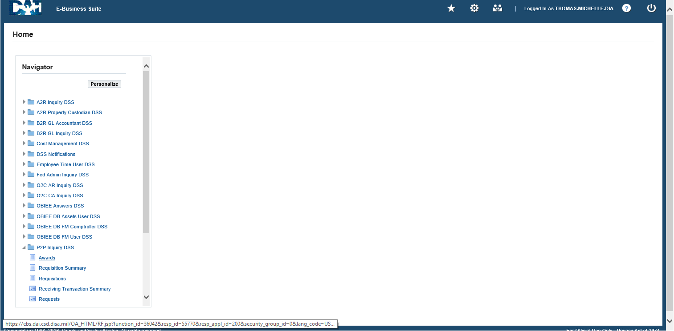
Click on Distributions
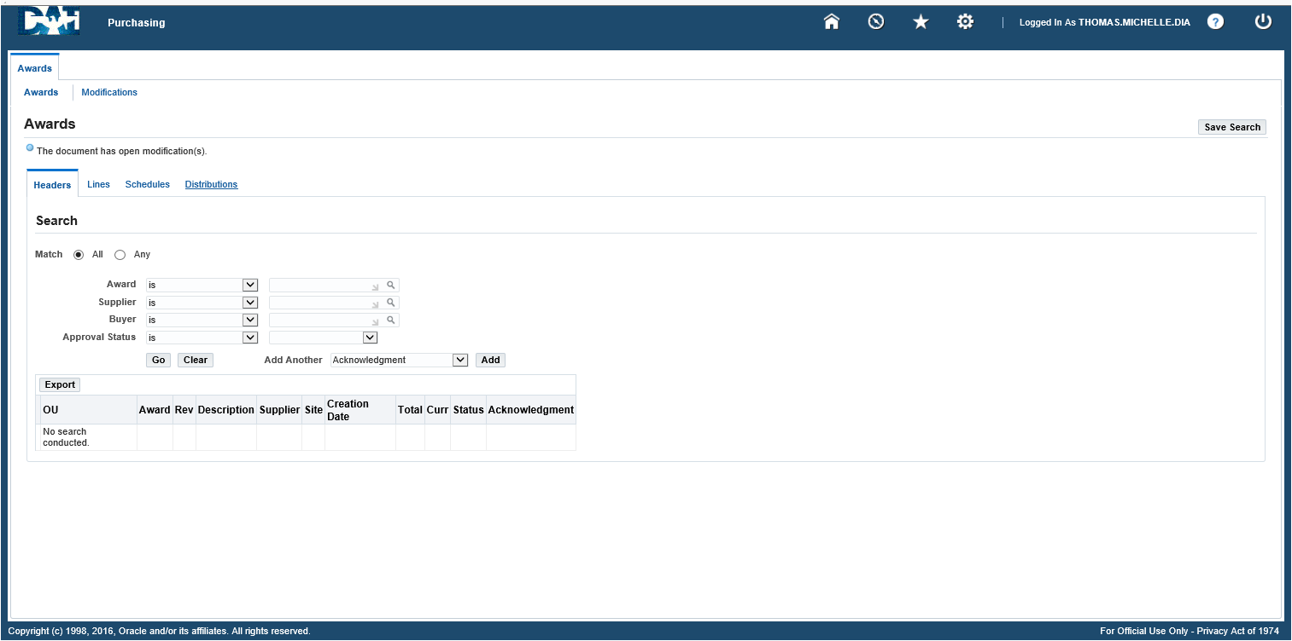
Select the drop down for Add Another then Select Award
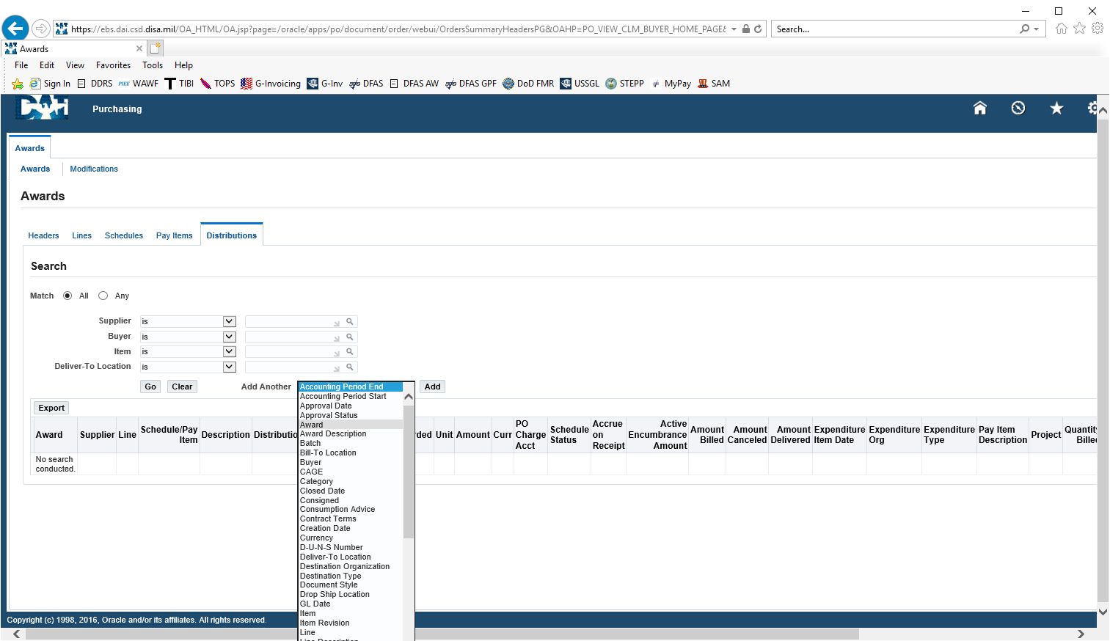
Enter the Award # (same as the PR#) then enter Go
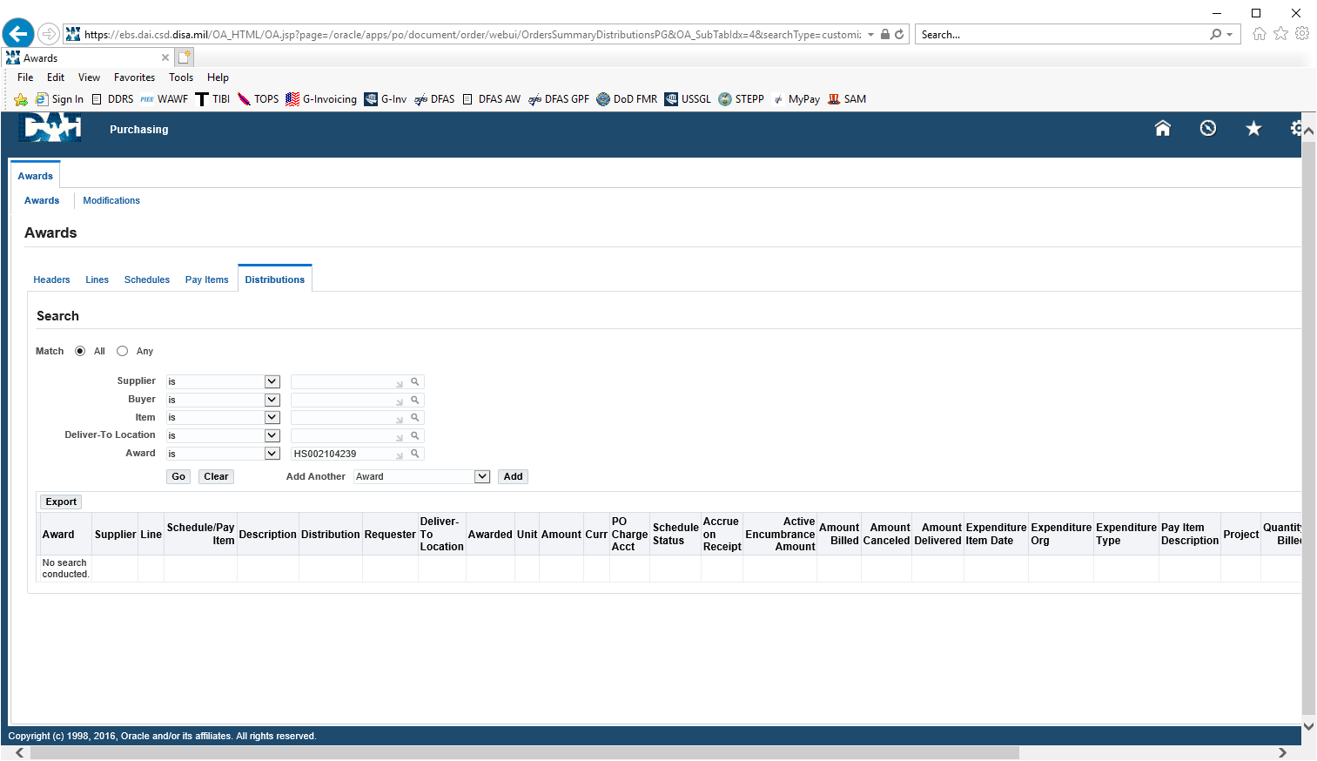
If the Reimbursement has been paid you will see it in the Amount Billed column
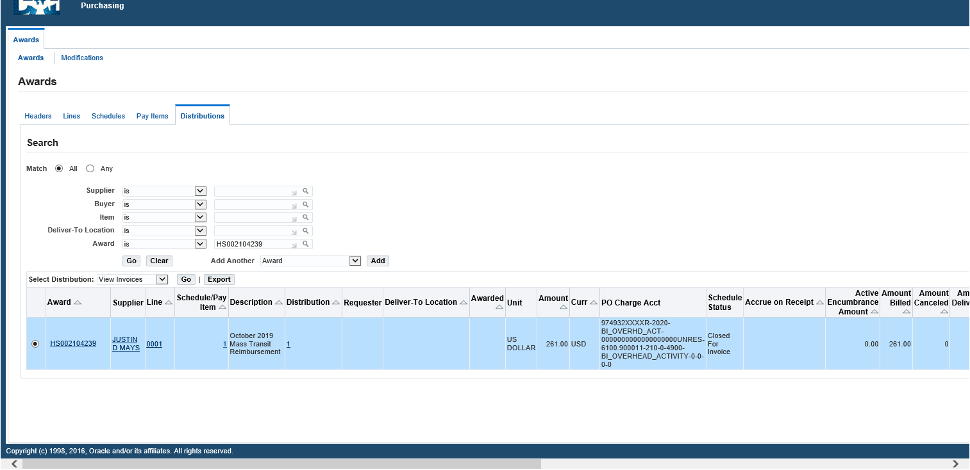
To see payment date:
Select the drop down on Select Distribution and select View Payment then Select Go
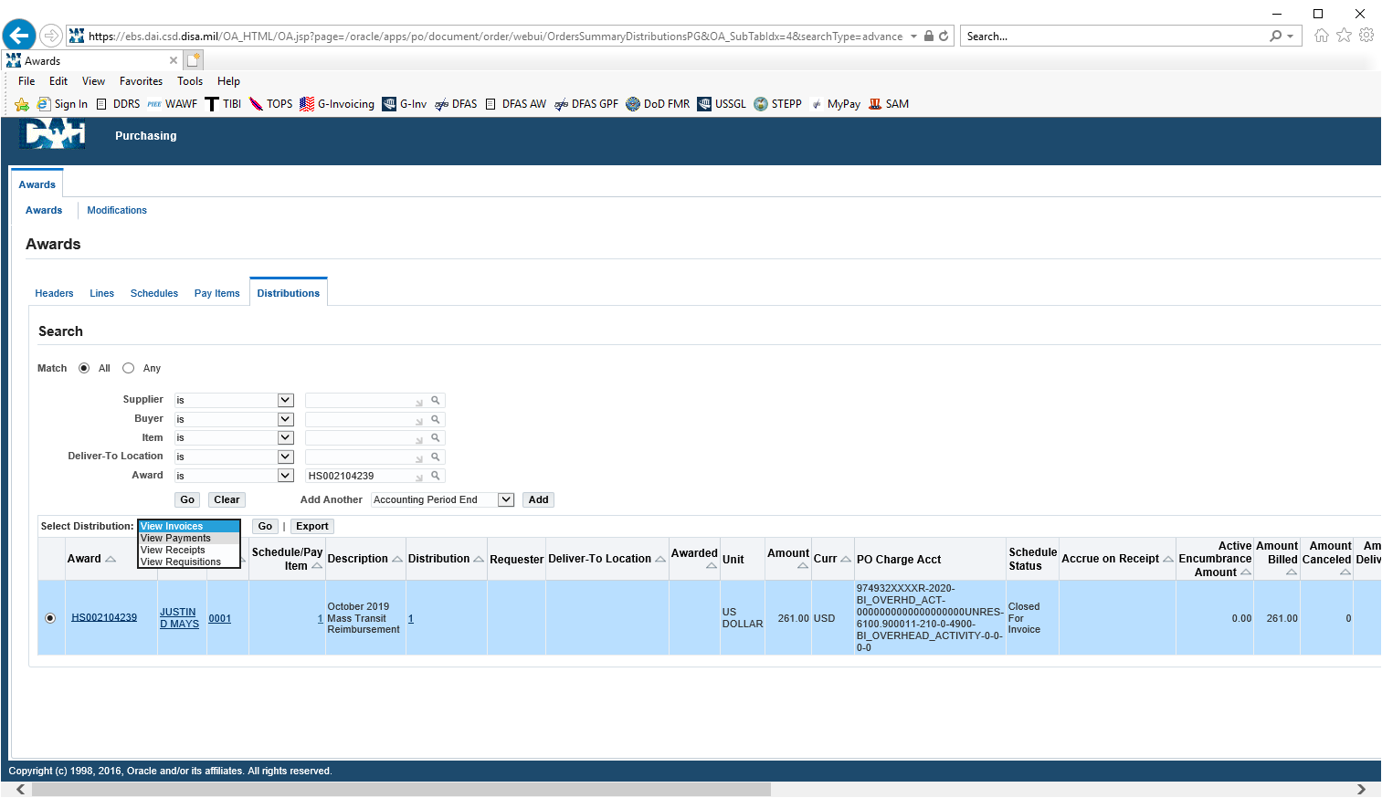
You will see the Employees Name, the Payment Date, the Amount, and How the Payment was made (Method: Electronic)
