Engage login
- Click the “Sign In” Button at https://engage.asmconline.org/home.
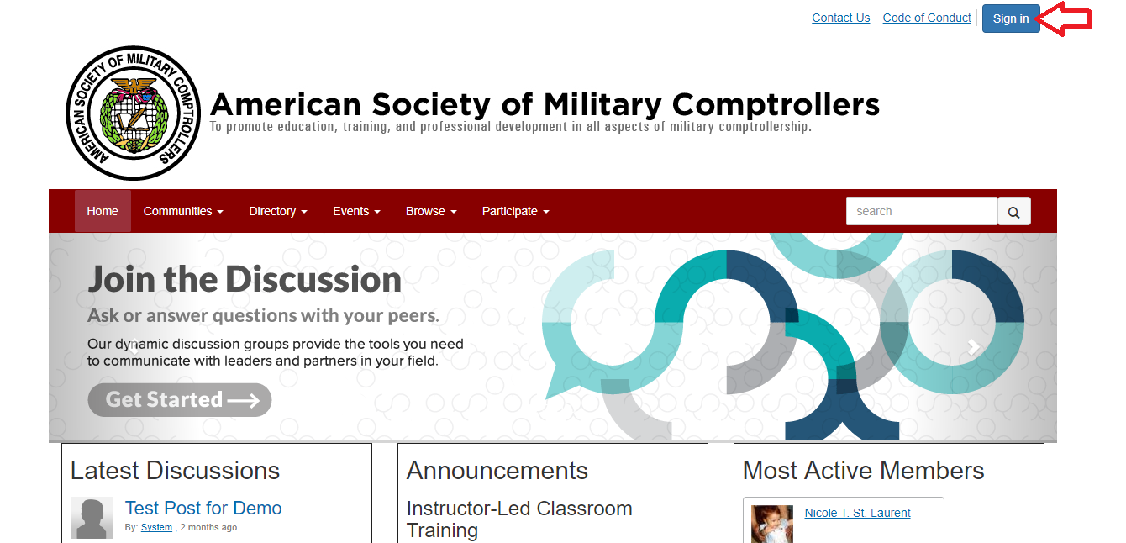

- Enter your ASMC member account login information when you get to the screen below and click “login”.
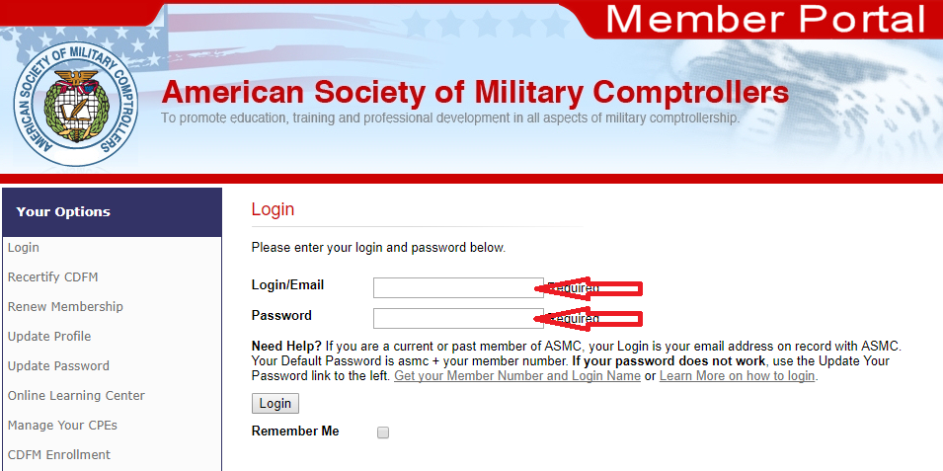

Engage Profile Editing
- Access your profile by clicking on the avatar, which will produce a small drop-down menu, then select the “Profile” option.
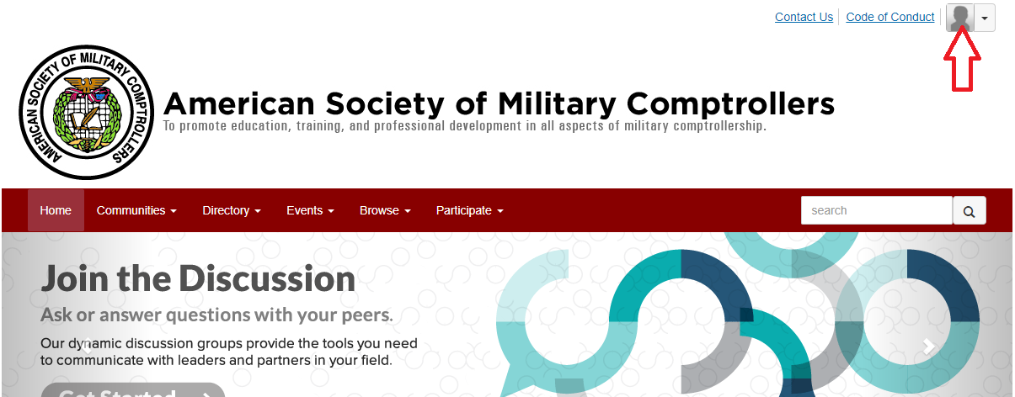

- Once you have arrived at the “Profile” screen (as shown below), click the pencil icon by contact details (underneath the blank profile picture):
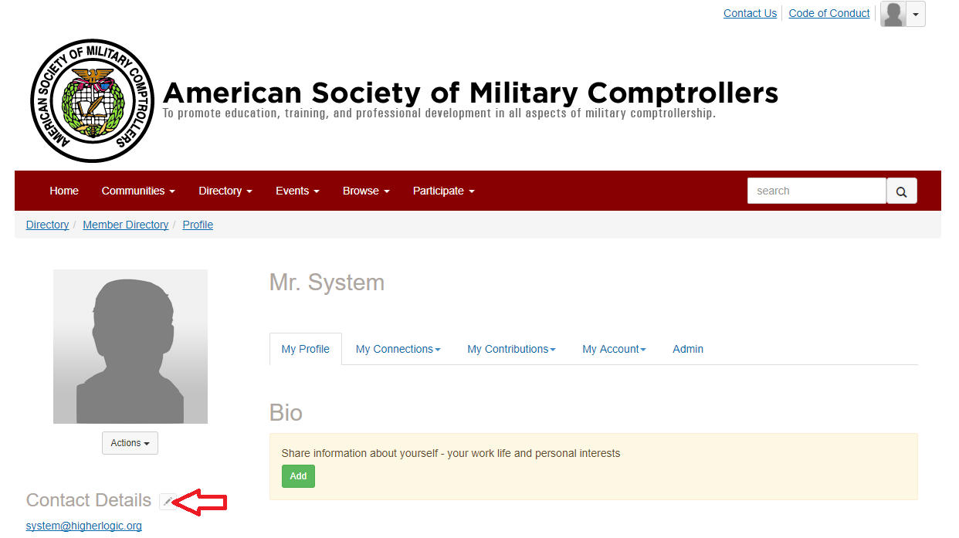

- If your contact information is missing or incorrect in Engage, click the pencil icon to edit the information. You will be taken to your ASMC member profile.
  - After changing the incorrect or missing information, click the “submit” button. When you’re done, you’ll need to go back to the previous page you were on to review the remainder of your profile information. The easiest way to do this is to hit your back button on your browser, and refresh the page.
- Log out and log back in to Engage (https://engage.asmconline.org/home) verify that the update to your profile is reflected.
Joining an Engage Community and Posting a Discussion
- Access the “Communities” tab on the Engage home screen. Click on “All Communities” which will bring you to a landing page of all communities available. See screen below.

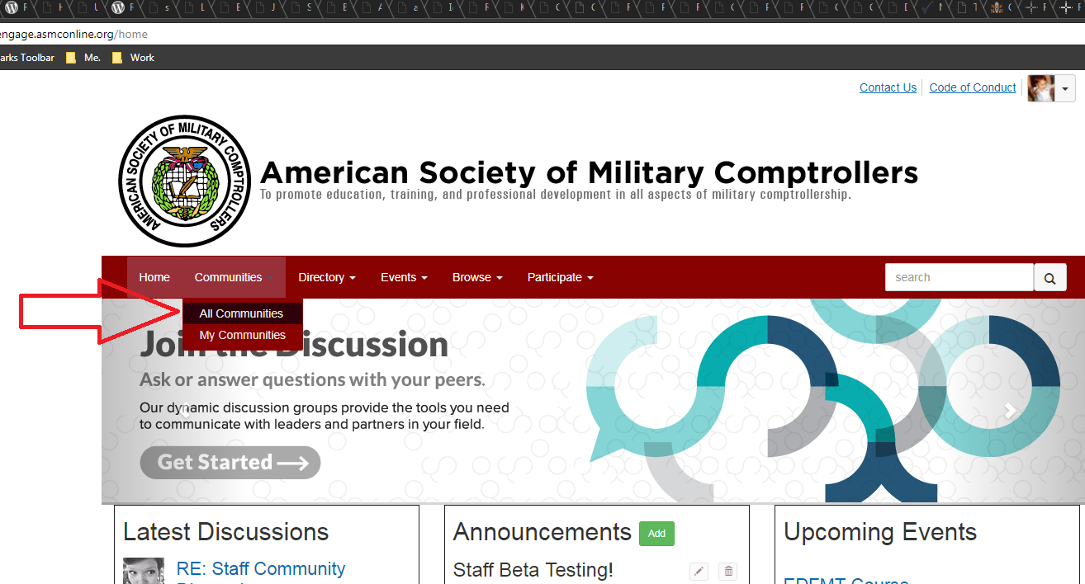

- You’re already a member of the “All Member” community! You can see this by the little gray box under “All Member” that says “member”. You can post and share information in this group!

- Choose and enter a community of which you are a member. Find the “Latest Discussion Posts” and click the green “Add” button. (See the example below of the ASMC Employees test group.)
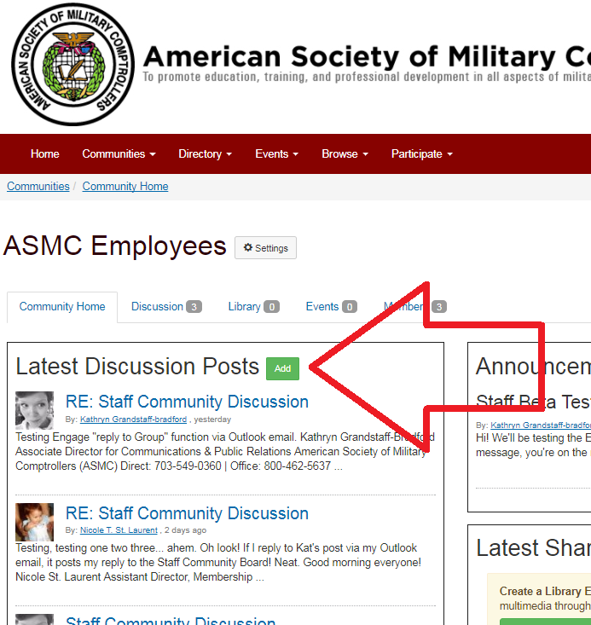
- Type subject, type message, attach a file (optional) then click send.
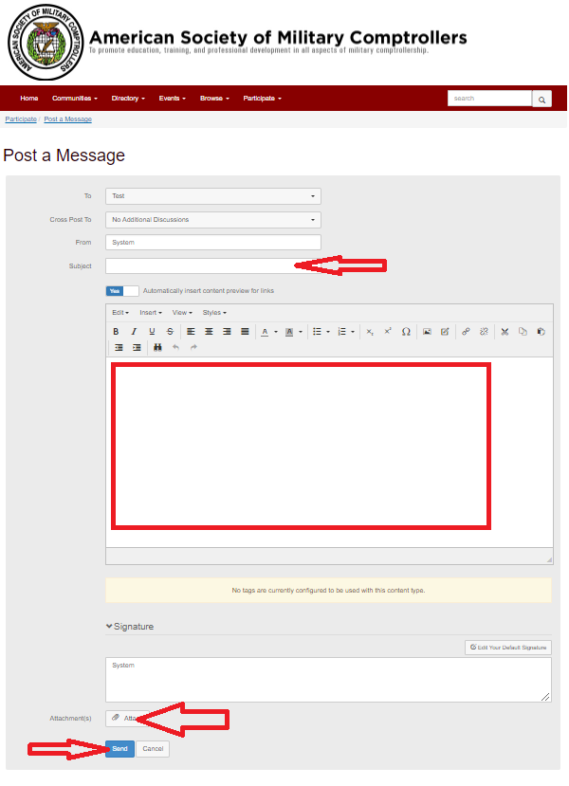
- Community discussion posts can be emailed to you as a daily digest email or a message for each new post. You can choose how to receive these community- related emails by setting your preferences under the “my account” tab – “community notifications” selection, as seen in my options below.

- You can also post by replying to a current discussion via email. To do this, simply hit “reply” to a community post e-mail message in your inbox. Replying to the message, as seen below, will automatically post to the select Engage group in which the original post was made.
(See the Staff testing – and having fun with! - this option below.)
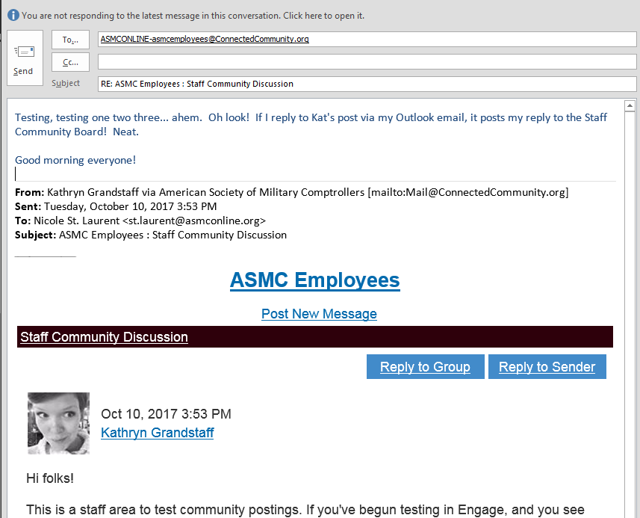

Here’s how that reply shows up in Engage:

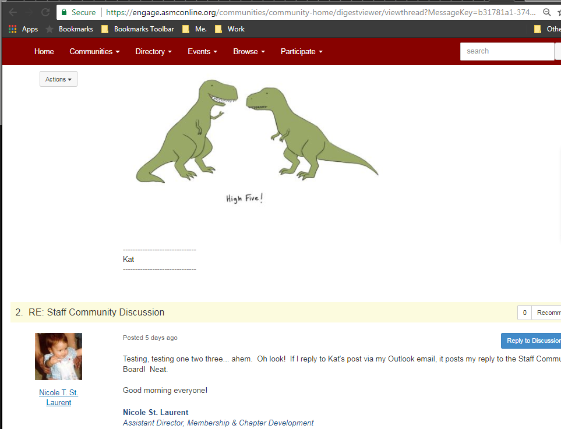
Posting a file/document as a Community Library Entry

- Still from within the “All Member” Community, click the library tab. (See the ASMC Employee library example below.)
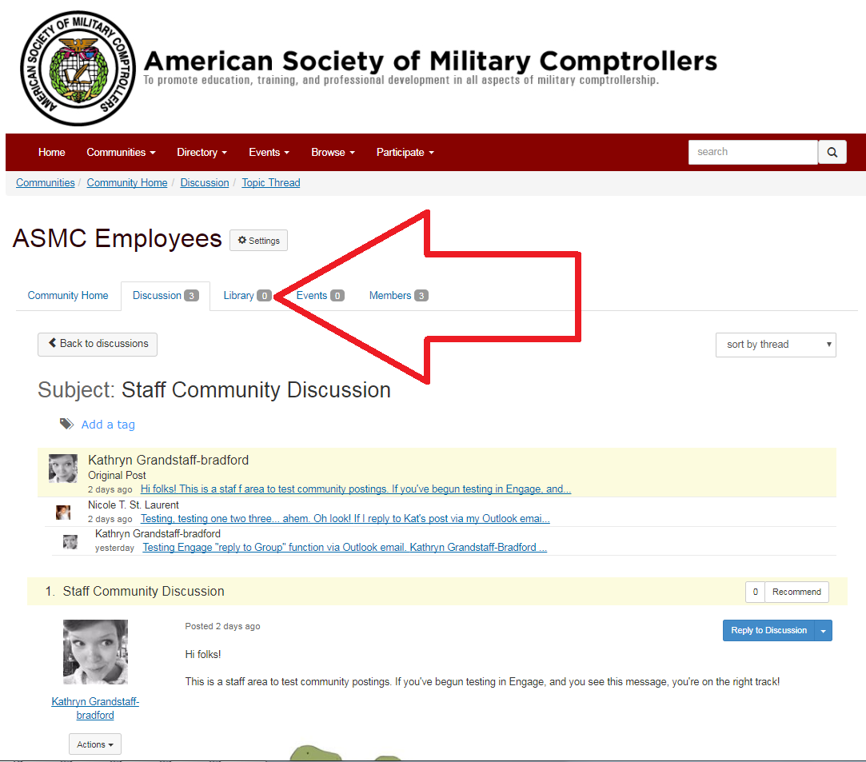
- Click the green create Library Entry button to add content and media files to the library.
- Enter Title, Description (optional) then click next
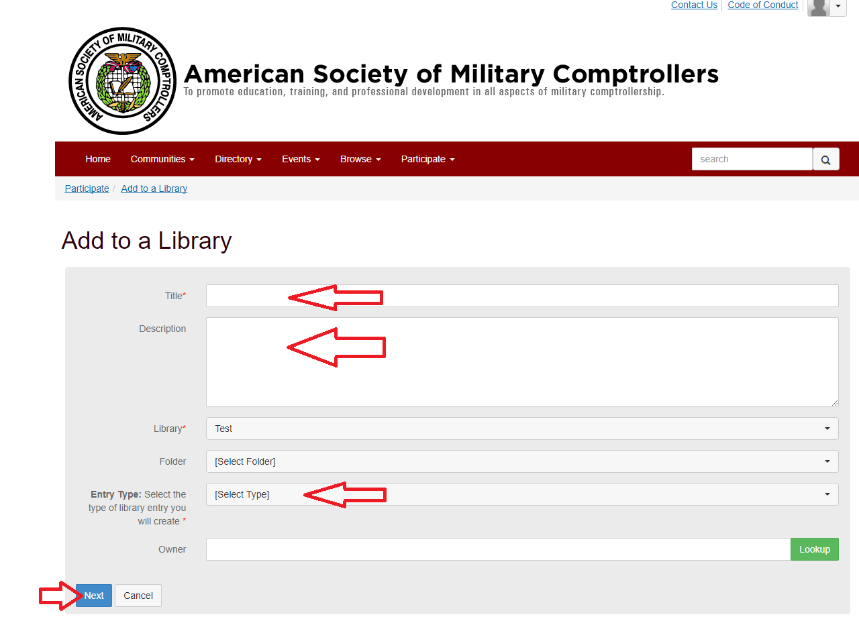
- Click Choose and Upload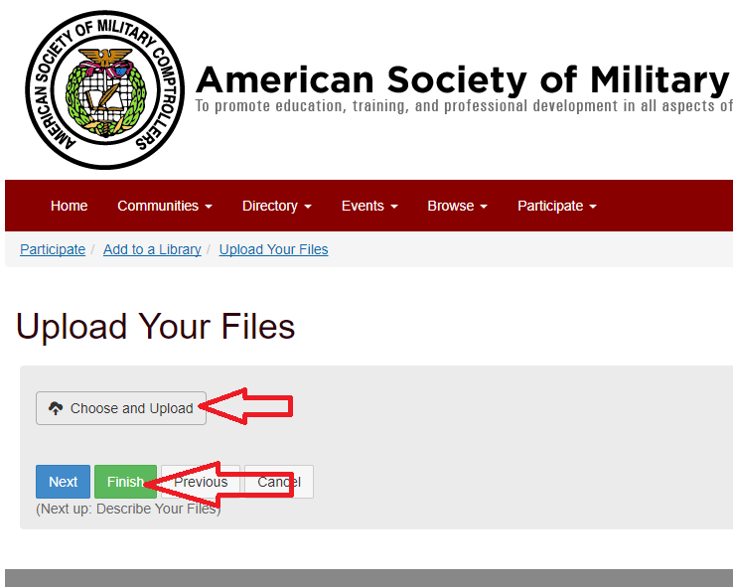

- Select your file you wish to upload.

- Click Finish.

