How to Pull a Trial Balance by Fund and Organization

Select “B2R GL Inquiry” – “Other” – “Reports” – “Run”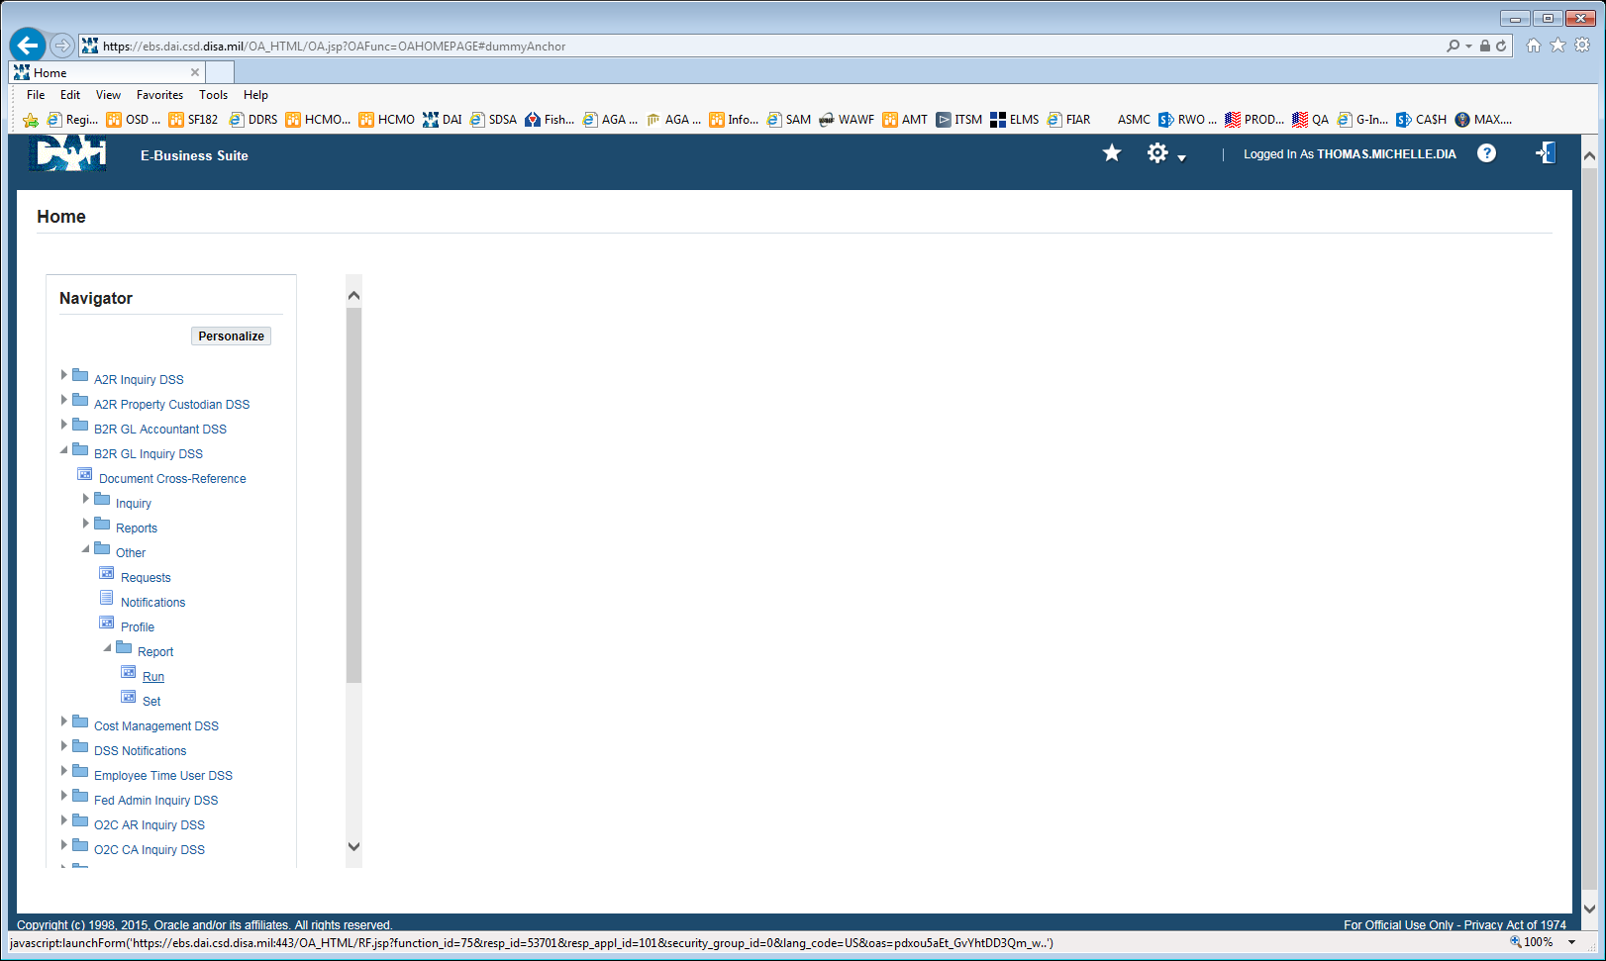

This will open Oracle

Select “OK”

Type in Trial and select Tab
Select the report named “Trial Balance – Additional Segment Detail”

Enter the data set you are pulling (this example is using 9701001717D but you can select multiple funds and years as well)
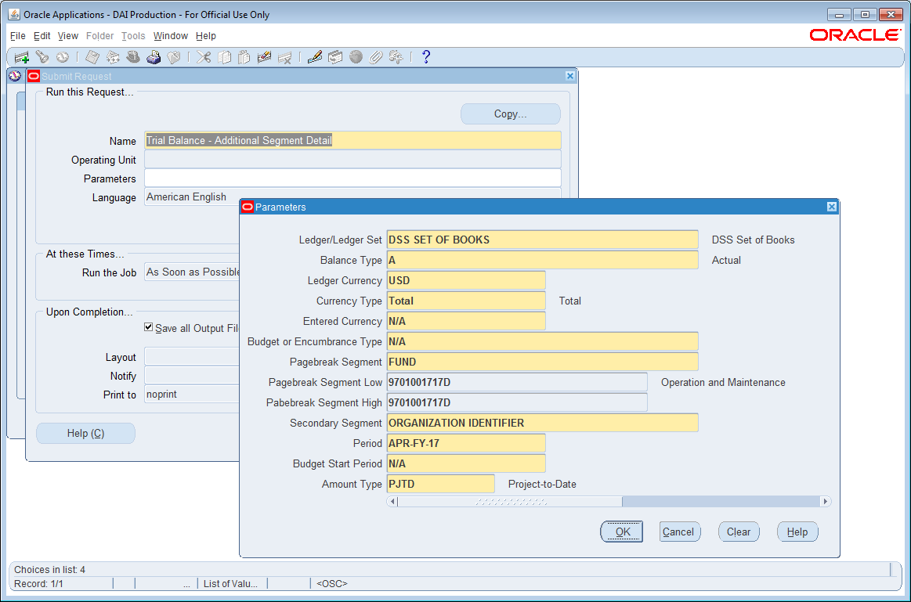

Select “Submit”
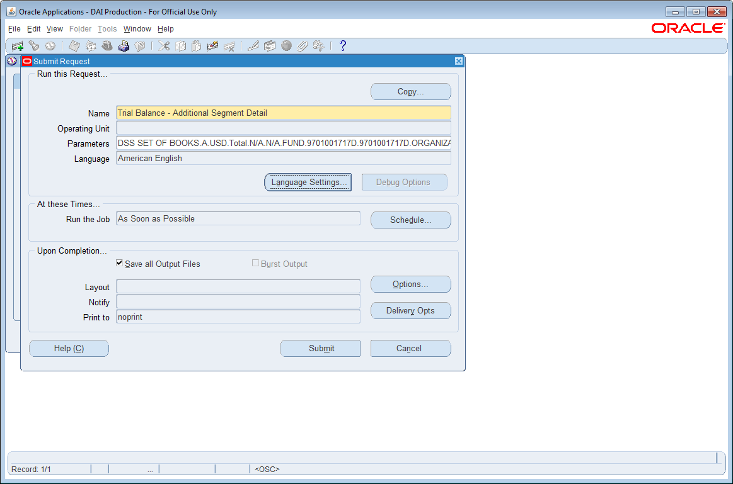

Select “No”
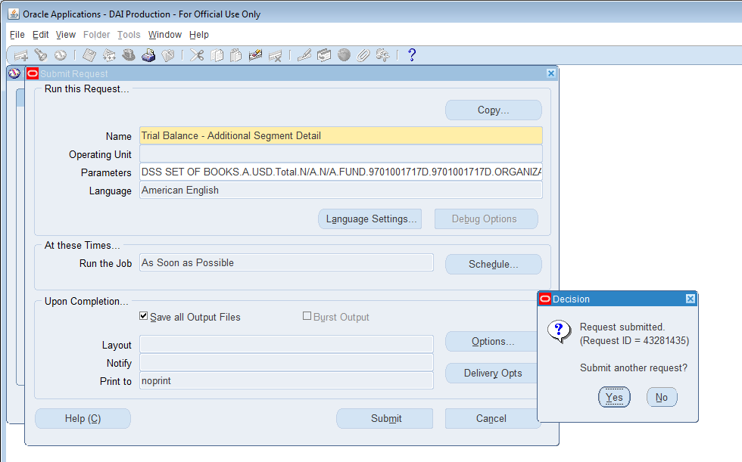

Select “View” then “Requests”

Select “Find”
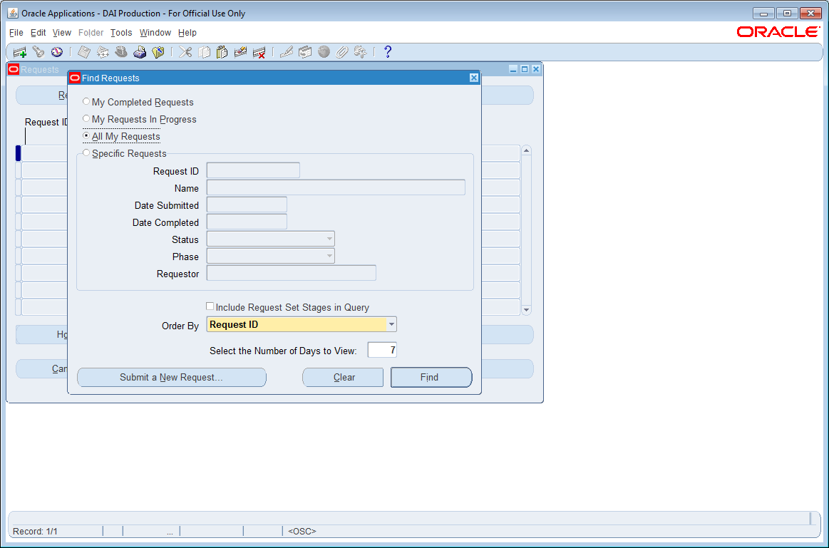

Select “View Output”

Trial Balance by Fund and Org
